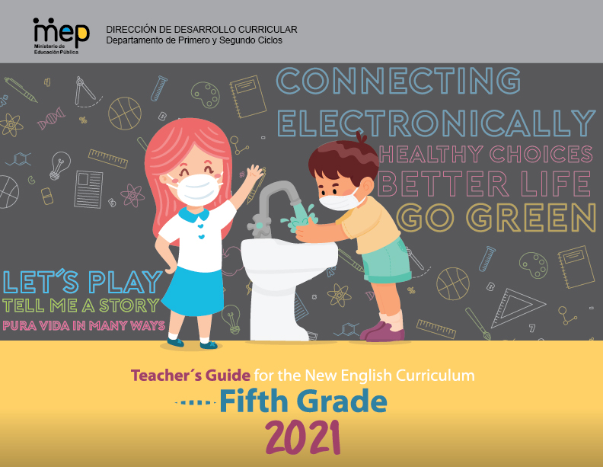

# **Presentation**

**Dear teachers**

This is unit 1 of Fifth Grade Teacher´s Guide and have the purpose to provide English teachers of Fifth grade with the guidelines on how to develop effectively the knowledge, skills and abilities set in the new English syllabus. As a result, learners can achieve an expected level of performance in the target language according to the CEFR. We believe that you know your students best and therefore we encourage you **to adapt and contextualized** what you find here so that it responds to the needs and context of your learner. This lesson plan includes in the first page of the planning template, the four dimensions of the new Curricular Policy, “To Educate for a New Citizenship”. The ones mostly emphasized in the unit are identified with an X. These dimensions are embedded and developed in the learning experiences provided. This unit will be completed within a timeline of six weeks.

The unit includes all the steps that should be followed in the pedagogical mediation which are:

A. **Assessment Strategies and Evidences of Learning:** Each goal has a specific assessment indicator for each linguistic competence that requires the elaboration of assessment instruments. Sample models of rubrics are provided

B. **Goals:** Each lesson has specific and clear learning goals connected to a domain, scenario, theme and language function.

C. **Pedagogical Mediation/ Didactic Sequence:** subdivided in the following stages;

✓**Pre-Teaching:** (Warm-up, Activation of Prior Knowledge, Modeling, Clarifying)

✓**Pre-task:** Introductory activity for activation of students’ prior knowledge to carry out a specific task connected to a goal. It places emphasis on the linguistic, cognitive resources needed by the leaner.

✓**Task rehearsal:** Class work where students practice the language in a meaningful way for successful task completion.

✓**Task completion:**  A task that learners perform to demonstrate that the goal has been successfully achieved.

✓**Task assessment:** An activity for reinforcement of the goal. It can also be used for self and/or peer assessment and teacher feedback and/ or repair in relation to the achievement of a goal. Evaluation tools to evaluate performance tasks, of what students know and can do.

D. **Time:** Each phase of the didactic sequence includes a suggestion for the time that may be needed.

E. **Integrated Mini Project:** The project is a creative opportunity for students to integrate knowledge, abilities and skills**.**

F. **Reflective Teaching:** Suggestions for you to assess your own progress in teaching the material.

G. **Enduring Understanding Reflection**: Space to record how students grasped new understandings and ideas in connection with the essential question of the unit.

|  |  |  |  |
| --- | --- | --- | --- |
| **Level 5th Unit 6**  **Scope and Sequence** | | | |
| |  | | --- | | **Dimensions** | | **1.** **Ways of thinking ( X )** | | **2. Ways of living in the world  ( X )** | | **3. Ways of relating with others  ( X )** | | **4. Tools for integrating with the world  ( )** | | | | |
| **Scenario: Let´s Play** | | | |
| **Enduring Understanding** | What people do for fun differs from one person to another not only because of likes and dislikes, but also because of personality, time and money. | | |
| **Essential  Question** | How do people play around the world? | | |
| **Assessment and Goals** | | | |
| **Week 1** | **Week 2** | **Week 3** | **Week 4** |
| **Theme**   1. What do you do for Fun? | **Theme**  2. Sharing Hobbies and Pastimes | **Theme**  3. Do you have Plans for the Weekend? | **Theme**  4. How Was your Weekend? |
| **Assessment:**  **L1.** Recognizes others’ preferences including greetings and expressions of politeness.  **R1.** Reads with fluency and accuracy (i.e., accuracy, intonation, and attention to punctuation).  **R.P.A.1.** Produces the 44 phonemes with verbal modeling and visual cues and practices minimal pair sounds: s / θ sin/ thin.  **SI.1.** Asks others simple questions concerning their homes (village/town) or their interests (e.g., Where do you live? What do you like?).  **Goals:**  **L.1.** understand others’ preferences including greetings and expressions of politeness.  **R.1.** read with fluency and accuracy.  **R.P.A.1.** produce the 44 phonemes of English with verbal modeling and visual cues.  **SI.1.** ask others simple questions concerning their homes (village/town) or their interests (e.g., Where do you live? What do you like?). | **Assessment:**  **L2.** Recognizes phrases and high frequency vocabulary related to areas of personal interest.  **R2.** Comprehends reading, analyzes and enjoys texts.  **R.P.A.1.** Produces the 44 phonemes with verbal modeling and visual cues and practices minimal pair sounds: s / θ sin/ thin.  **SI.1.** Asks others simple questions concerning their homes (village/town) or their interests (e.g., Where do you live? What do you like?).  **Goals:**  **L.2.** understand phrases and high frequency vocabulary related to areas of personal interest.  **R.2.** comprehend readings, analyze and enjoy texts.  **R.P.A.1.** produce the 44 phonemes of English with verbal modeling and visual cues.  **SI.1.** ask others simple questions concerning their homes (village/town) or their interests (e.g., Where do you live? What do you like?). | **Assessment:**  **SI.1.** Asks others simple questions concerning their homes (village/town) or their interests (e.g., Where do you live? What do you like?).  **R.P.A.2.** Distinguishes spoken rhyming words from non-rhyming words. (e.g., run, sun versus run, man, etc).  **SP.1.** Describes basic aspects of an event.  **W.1.** Composes short texts expressing wants and preferences.  **W.2.** Composes short invitations using simple language.  **Goals:**  **SI.1.** ask others simple questions concerning their homes (village/town) or their interests (e.g. Where do you live? What do you like?).  **R.P.A .2.** distinguish spoke rhyming words from non-rhyming words. (e.g., run, sun versus run, man, etc).  **SP.1.** describes basic aspects of an event.  **W.1.** compose short sentences expressing wants and preferences.  **W.2.** compose short invitations. | **Assessment:**  **SI.2.** Asks how to express something in English.  **R.P.A.2.** Distinguishes spoken rhyming words from non-rhyming words. (e.g., run, sun versus run, man, etc).  **SP.2.** Talks about a familiar topic in a short presentation.  **Goals:**  **SI.2.** ask how to express something in another language  **R.P.A .2.** distinguish spoke rhyming words from non-rhyming words. (e.g., run, sun versus run, man, etc).  **SP.2.** talk about a familiar topic in a short presentation. |
| **Function**   * Describing preferences related to hobbies and fun activities | **Function**   * Describing hobbies and pastimes | **Function**   * Describing future plans related to hobbies | **Function**   * Describing past events |
| **Discourse Markers**  Sequence adverbs-past tense  First, next, then, finally | **Discourse Markers**  Sequence adverbs-past tense  First, next, then, finally | **Discourse Markers**  Sequence adverbs-past tense  First, next, then, finally | **Discourse Markers**  Sequence adverbs-past tense  First, next, then, finally |
| **Grammar & Sentence Frames**  Simple Preset Tense   * I like to _____. * I do not like to ____. * My favorite (sport) ____ is ____.   Interrogatives   * What do you do for fun? * How do you play __? * How often do you______? | **Grammar &Sentence Frames**    Present Perfect   * How long have you been playing soccer? I started two years ago. * How long have you been playing the guitar? Since I was in second grade. | **Grammar & Sentence Frames**   * Future with going to/will   I´m going to play soccer with my friends tomorrow.  I will go skating this weekend. | **Grammar & Sentence Frames**  Past Simple  I had a great weekend, I went to the (movies)_____ with my friends. |
| **Phonemic Awareness**  Practicing minimal pair sounds**: s / θ**  **sin/ thin, sum/ thumb, sank/ thank,**  **sink/ think, saw/ thaw** | **Phonemic Awareness**  Practicing minimal pair sounds**: s / θ**  **sin/ thin, sum/ thumb, sank/ thank,**  **sink/ think, saw/ thaw** | **Phonemic Awareness**  Distinguishing spoken rhyming words from non-rhyming words. (e.g., run, sun versus run, man, etc). | **Phonemic Awareness**  Distinguishing spoken rhyming words from non-rhyming words. (e.g., run, sun versus run, man, etc). |
| **Vocabulary**  1. What do you do for fun?  Expressions and phrases   * What sort of hobbies do you have? * My favorite sport activity is _____. * In my free time, I like/ I don´t like to   ___  Hobbies   * go to the movies, go to the beach, play computer games   Sports   * Soccer, cycling, surfing,   Pastimes   * dancing, listening to music, playing chess | **Vocabulary**  2.Sharing hobbies and pastimes  Expressions and phrases   * What do you do for fun? I am crazy about listening to rock music. * How did you choose that hobby? I am an outgoing person, I like dancing. * How long have you been collecting stamps? Three years ago.   Fun activities and hobbies  dancing, martial arts,  Descriptive adjectives  creative fascinating cheap relaxing different | **Vocabulary**  3. Do you have plans for the weekend?  Expressions and phrases   * Are you busy on Sunday? * Do you want to hang out? * I am going to play soccer with Mike * I will sing karaoke. * She will ride on bike with her friends.   Fun activities and hobbies  Playing the violin, skateboarding, snorkeling | **Vocabulary**  4. How was your weekend?  Expressions and Phrases   * What did you do this weekend? I played chess with my friend. * Where did you go? I went to the stadium. * How was the weather? It was very hot.   Sports and hobbies  soccer, volleyball, golf, surfing, skateboarding |
| **Psycho-social**   * Respecting other customs and ways of entertainment   **Sociocultural**   * Identifying cultural differences among contexts in terms of hobbies and sports   **Idioms/phrases**   * I`m very interested in… | **Psycho-social**   * Expressing creativity when communicating owns ideas   **Sociocultural**   * Identifying cultural differences among contexts in terms of hobbies and sports   **Idioms/phrases**   * I love to… | **Psycho-social**   * Working cooperatively with others   **Sociocultural**   * Comparing traditional games in CR and around the world   **Idioms/phrases**   * You are barking up the wrong tree= you´ve got the wrong person or idea. | **Psycho-social**   * Working cooperatively with others   **Sociocultural**   * Comparing traditional games in CR and around the world   **Idioms/phrases**  The ball is in your court. =It is your responsibility to do something now. |

|  |  |  |  |  |  |  |  |  |  |
| --- | --- | --- | --- | --- | --- | --- | --- | --- | --- |
| **Term:** | | **Level: Fifth Grade** | | | **Unit:** | | | **Week:1** | |
| **Domain: Socio-interpersonal** | | | | **Scenario: Let´s Play** | | **Theme:**  What do you do for Fun? | | | |
| **Enduring Understanding**: What people do for fun differs from one person to another not only because of likes and dislikes, but also because of personality, time and money. | | | | | | | | | |
| **Essential Question:** How do people play around the world? | | | | | | | | | |
| |  | | --- | | **Dimensions** | | **1.** **Ways of thinking ( X  )** | | **2. Ways of living in the world  ( X )** | | **3. Ways of relating with others  ( X )** | | **4. Tools for integrating with the world  ( )** | | | | | | | | | | |
| **Learn to Know** | | | | **Learn to Do** | | **Learn to Be and Live in Community** | | | |
| **Grammar & Sentence Frames**  Simple Preset Tense   * I like to _____. * I do not like to ____. * My favorite (sport) ____ is ____.   Interrogatives   * What do you do for fun? * How do you play __? * How often do you______?   **Phonemic Awareness**  Practicing minimal pair sounds**: s / θ**  **sin/ thin, sum/ thumb, sank/ thank,**  **sink/ think, saw/ thaw**  **Vocabulary**  1. What do you do for fun?  Expressions and phrases   * What sort of hobbies do you have? * My favorite sport activity is _____. * In my free time, I like/ I don´t like to   ___  Hobbies   * go to the movies, go to the beach, play computer games   Sports   * Soccer, cycling, surfing,   Pastimes   * dancing, listening to music, playing chess | | | | **Function**  Describing preferences related to hobbies and fun activities  **Discourse Markers**  Sequence adverbs-past tense  First, next, then, finally | | **Psycho-social**   * Respecting other customs and ways of entertainment   **Socio-cultural**   * Identifying cultural differences among contexts in terms of hobbies and sports   **idioms/ phrases**  I`m very interested in… | | | |
| **Assessment Strategies & Evidences of learning**  (Diagnostic, formative, summative) | **Goals** | | | **Pedagogical Mediation/ Didactic Sequence** | | | | | **Time** |
| Learner… | Learner can | | | **Pre-teaching**  **Routine:** Greetings / Prayer/ Weather conditions and the date. Checking attendance, teacher posts the Essential Question on the board, goals, and class agenda, etc.  **Essential Question:** How do people play around the world?  **Warm up**  Teacher uses this video on hobbies**: In the following link**, you willfind  <https://www.youtube.com/watch?v=90LfcLAjLiI>    and asks students to pay attention to the hobbies mentioned. Then, students say the words they can remember.  **Activation of Prior Knowledge**  **Get to know some vocabulary:** Teacher pastes in the board some names of hobbies **(annex 1)** and asks what they think each one is? What is the meaning of each one? Teacher can write on board some of the names Students give: Swimming, playing the guitar, bike riding, reading books, etc.    **Modeling**  Teacher plays the video one more time and ask Students for some hobbies and fun activities they practice, or they like or don´t like to do.  Teacher introduces the new sentence frames and reviews some greetings like:   * Hello! How are you? * What´s your hobby? * What do you like to do? * What is fun for you? * My hobby is ______   Teacher pronounces the structures and vocabulary. Students repeat after the teacher.  **Clarifying**  Teacher asks questions to students like (What do you do for fun? How do you play __? How often do you play video games? What is your favorite hobbies/ fun activity? )  Teacher monitors students to make sure they are understanding the meanings of the new vocabulary. | | | | | 40 minutes |
| **L1.** recognizes others’ preferences including greetings and expressions of politeness.  INDICATORS  **L.1.1.** identifies greetings, expressions of politeness and people’s preferences when listening to oral exchanges or texts.  **L.1.2.** recognizes greetings, expressions of politeness and people’s preferences when listening to oral exchanges or texts. | **L.1.** understand others’ preferences including greetings and expressions of politeness. | | | **Pre-task**  Teacher shares the goal of the lesson with students.  Teacher reviews sentences’ frames and vocabulary using a video one more time. In the following link, you can find a video about key phrases and vocabulary: <https://www.youtube.com/watch?v=90LfcLAjLiI>  Teacher introduces new phrases and expressions about hobbies and interests. Teacher shows flashcards or pictures about some hobbies and activities students do for fun. (**annex 2- ppt1)**    Teacher models some questions while showing the flashcards:  Hello! How are you? __________________________  What´s your favorite hobby? My favorite hobby is _______  What do you do for fun? I like to ________  What do you like to do in your free time? I like to _______  What else do you like to do? I also like to ___________  **Task-rehearsal**  Teacher gives students different pictures. Then teacher says a greeting, question and an answer.  For example: Hello! *What do you do for fun? I like to play the guitar.*  The students listen carefully to each question and answer. Then, the one who has the picture mentioned **(**PLAY THE GUITAR) has to stand up and raise it, and repeat the sentence frame teacher just said. “**Hello! I like to play the guitar”.**  Teacher continues saying other, greetings, questions and answers (Hi! What do you do for fun? **I like to ______)** as many times as flash cards students have.  **Task completion**  There are four friends talking about their hobbies. Listen to their conversation in this video for the first time. Can you identify the following information? Where are they? Why are they talking about hobbies? Did you listen to any type of greetings or expressions of politeness? Play the video only 1:30s. In the following link, you can find a video about a conversation between friends talking about hobbies: <https://www.youtube.com/watch?v=tgVtVoxzwDI&t=10s>  Dos niñas y dos niños conversando sobre sus intereses, una niña es rubia, la otra peliroja. Un niño tiene cararcteristicas afordescendientes y el otro es rubio.  Students share their answers as a whole group and agree about the correct responses guided by the teacher.  Then, they listen to the conversation a second time and solve this task.  Can you identify the hobbies of John and Olivia by completing this chart?   |  |  | | --- | --- | | Names of friends | Types of hobbies | | John |  | | Olivia |  | |  |  |   The students sit in pairs to check their responses. The teacher calls students at random to share the answers with the group and gives feedback.  **Post task**  1. Students talk about their favorite hobbies and interests in pairs.  Students will survey their classmates in order to find out information about hobbies and interests.   |  |  |  |  | | --- | --- | --- | --- | | **Questions** | **Classmate # 1** | **Classmate # 2** | **Classmate # 3** | | What do you like to do in your free time? What´s your hobby? |  |  |  | | What else do you like to do/practice? |  |  |  | | | | | | 40 minutes |
| **R1.** reads with fluency and accuracy (i.e., accuracy, intonation, and attention to punctuation).  INDICATORS  **R.1.1**.reads aloud a short text or narration with good intonation and speed to make it comprehensible.  **R.1.2.** reads words and sentences within a narration related to hobbies and favorite activities with good pronunciation and with attention to punctuation and pauses.  **R.1.3.** reads aloud with accuracy and fluency a short text related with hobbies and pastimes to support comprehension of listener. | **R.1.** read with fluency and accuracy. | | | **Pre-task**  Teachers introduces the goal of the lesson.  Teacher introduces different strategies that can help students to read with fluency and good intonation like:  **How to be a good story teller**  Look for clues in the pictures of the text about the characters  Look at the speaker´s tags and punctuation. “Listen!” “Can you hear it?”  Think about how the character is feeling? How can you express his/her emotions through his voice?  You can see them in more detail in the following video:  <https://www.youtube.com/watch?v=Gr1vs2QaZrc>  The students listen to a model reading about how to apply these strategies.  Students practice the strategies  After this first practice, teacher plays a second video to explain what reading with fluency means: <https://www.youtube.com/watch?v=wsDPrZnRxic>  El cuadro muestra cinco aspectos a considerar para leer con fluidez tales como: Accuracy, phrasing, punctuation, rate and expression.  Focus first on how to read with accuracy. Play the video where students listen to a model.  Learners practice repeating and reading the story as they hear it. Students continue learning about phrasing, punctuation, rate and expression as necessary strategies when reading with fluency and accuracy. Students continue repeating and practicing as it is shown in the video.  **Task rehearsal**  Students will practice reading aloud applying the principles of fluency, phrasing, punctuation, rate and expression using the story in the video. A picture of the story appears below.  It cuadro muestra un extracto de la historia de la hormiga y el saltamontes.  Fuente: <https://www.youtube.com/watch?v=wsDPrZnRxic>  As the students read, the teacher provides feedback.    **Task completion**  Before reading  Teacher shows students the picture of Captain Storm, and asks them what they think about the content of the story will be about**.**  They shortly brainstorm and write on board the activities the captain might like to do and the ones he might not like to do.   |  |  | | --- | --- | | * **Likes** | * **Dislikes** |   Students read the story and look for new vocabulary by circling the words they don´t understand. Teacher clarifies the meaning of the words and the corresponding pronunciation. Students are asked to repeat the pronunciation of the new words.  First reading aloud  Now, teacher tells students to read the story called: **“Captain Storm Hobbies”** individually (**annex #3**)**.** As they read the story, they will be aware of the principlesoffluency, phrasing, punctuation, pronunciation, rate and expression  Second reading aloud  **Task:** In pairs, read the story to a partner. As you read the story, your partner will listen to you and will provide you feedback using the following checklist. Then, you will listen to your partner and follow the same procedure.    **Reading with fluency and expression- Peer assessment checklist**   |  |  |  | | --- | --- | --- | | Aspects to pay attention | YES | NO | | When reading the story, my partner… | | | | 1. reads smoothly with few pauses. |  |  | | 2.makes pauses only to stress words and due to punctuation marks |  |  | | 3.reads with feeling and emotion. |  |  | | 4. reads all the words with good pronunciation. |  |  |   **Task assessment**  Students read again the text again. They can record their voices and participate in a process of self-assessment using the following the checklist.   |  |  |  | | --- | --- | --- | | Aspects to pay attention | YES | NO | | When reading the story, I | | | | 1. read smoothly with few pauses. |  |  | | 2. make pauses only to stress words and due to punctuation marks. |  |  | | 3. read with feeling and emotion. |  |  | | 4. read all the words with good pronunciation. |  |  |   Finally, different volunteer students are called to read some sentences from the story as the teacher indicates. Teacher and peers provide specific feedback.  **Post-task**  Students read the text for comprehension and complete a chart with personal information about Captain Storm’s hobbies and interests.   |  |  | | --- | --- | | **QUESTION** | **ANSWER** | | 1- How old is the captain? |  | | 2- What is Captain Storm good at? |  | | 3-What day does Captain Storm do exercise? |  | | 4-Where does Captain Storm live? |  | | 5-What does he do on Saturday? |  |   Students read the story again and they will answer some reading comprehension questions.   |  |  | | --- | --- | | 1-What is the name of the Captain?  2-How old is Captain Storm?  3-What are the names of his friends? | 4-What is Captain Storm favorite hobby?  5-What is Captain Storm good at? 6-What is not good at doing? |     Students can answer those questions in their notebooks.  Finally, teacher invites different students to read aloud the story. | | | | | 40 minutes |
| **R.P.A.1.** produces the 44 phonemes with verbal modeling and visual cues and practices minimal pair sounds: s / θ sin/ thin.  INDICATORS  **R.P.A.1.2**. recognizes the pronunciation of minimal pair sounds: s / θ as they appear in list of words or sentences.  **R.P.A.1.3**.reads words and sentences that contain the minimal pair sounds: s / θ sin/ thin correctly. | **R.P.A.1.** produce the 44 phonemes of English with verbal modeling and visual cues. | | | **Pre-task**  Teachers introduces the goal of the lesson  Teacher shows a video to the students and asks them to pay attention to the pronunciation of each sounds (/s/ and /θ/)  In the following link, you will find a video about the pronunciation of the sounds(/s/ and /θ/): <https://www.youtube.com/watch?v=coI1jElTEls>  Teacher explains how to produce the sounds /s/ and /θ/. Then the teacher will write some examples on the board:   |  |  | | --- | --- | | **/θ/**  **think**  **thick** | **/s/**  **sink**  **sick** |   **Task-rehearsal**  Teacher gives students a set of words. Students are asked to pronounce them correctly.  Students work in pairs and back to back. Student A will say a word from the minimal pair and student B will identify the word mentioned. (**use annex 4**)  For example:  Student A: “sink”  Student B: “that´s picture in column B”  Teacher monitors the pronunciation of each pair of students.    **Task completion**  Teacher shows another video and students have to read and listen to the pronunciation of each word (minimal pairs).  In the following link, you will find a video about the pronunciation of the sounds(/s/ and /θ/): <https://www.youtube.com/watch?v=oJXlff0gaD8>  Then the teacher writes on the board the different minimal pairs from the video:  **Thick sick**  **Thumb some**  **Thank sank**  **Thong song**  **Think sink**  **Thigh sigh**  Students work in pairs. Student A reads one word from the minimal pairs and student B will identify the word heard.  Then teacher asks a student to read the words to the class and sends another student to the board to circle all the word that contains the sound / θ / or /s/  Students are given sentences that contain words with the sound / s / θ/. In pairs, they read the sentences aloud to the partner. Each student focuses on pronouncing the sounds / s / θ/ correctly. The partner who is listening writes a checkmark next to each word pronounced correctly and circles the ones that need more practice.   1. Six thick thistle sticks. 2. Elizabeth's birthday is on the third Thursday of this month. 3. The seventh boat sank this month.   Then teacher asks volunteer students to read the sentences to the class and sends another student to the board to circle all the word that he/she hears contains the sound / θ / or /s/. Teacher provides feedback to the group when all the sentences has been read.  **Task assessment**  Students get a worksheet for them to complete the words with the correct letter (s / th) according to the drawings. Teacher will go around the class and will pronounce the words if it necessary.  Teacher projects the picture on the board and calls students to say each word correctly. (**use annex 5**).  Caudro con imagenes que contienen palabras con los sonidos /s/ y /θ/.  At the end of the lesson, teacher provides feedback as a form of assessment on the pronunciation of the sounds(s / th) | | | | | 40 minutes |
| **SI.1.** asks others simple questions concerning their homes (village/town) or their interests (e.g., Where do you live? What do you like?).  INDICATOR  **SI.1.1.** asks others simple questions concerning their homes (village/town) or their interests (e.g., Where do you live? What do you like?) in an informal exchange. | **SI.1.** ask others simple questions concerning their homes (village/town) or their interests (e.g., Where do you live? What do you like?). | | | **Pre-task**  Teacher shares the goal of the lesson with students.  Students are introduced to the following conversation format with examples of sentence frames and vocabulary in context.  A: Hi, what’s your favorite hobby?  B: My favorite hobby is _____________, and you?  A: I like to __________________________  B: What do you love to do?  A: I love to _____________________, but I don`t like ___________________  B: Me neither, I like to ___________________________. See you.  Teacher and students complete the conversation together. (**use annex # 6**)  Students read the conversation with the teacher.  Teacher checks and clarifies.  **Task-rehearsal**  Students are given the following task to work in pairs. You are having a conversation with your best friend about your hobbies and interest. Using the information as a guide in the **annex # 6** to learn about your friend´s hobbies asking him/her questions like:  1. Do you have any hobbies?  2. What do you like to do in your free time?  3. What do you like to do during the weekend?  Listen to your friend´s answers and try to identify the things you have in common.   |  |  | | --- | --- | | Hobbies/ interest we share | Hobbies/ interest we don´t share | |  |  |   **Task completion**  You are planning a trip with three of your best friends to the beach. You are in charge of making a plan for all the activities that you will be doing together. You need to ask them about their hobbies and interests. Use the following steps as a guide:   1. Greet three of your best friends. 2. Ask them about their favorite activities/ hobbies? 3. Make a list and complete this chart.  |  |  | | --- | --- | | Hobbies/interest we share | Activities we don´t share | |  |  | |  |  |   Be ready to report to your friends about the things that all members in the group like and will do during the trip.  **Task assessment**  By throwing a ball to a classmate, students make questions about hobbies and fun activities to their classmates. Students will answer with the help of the pictures in the handout (**annex #7**).  **Imagenes con distintos tipos de actividades y las palabras en inglés para expresarlo. Los estudiantes deben asociarlos.Example:**  Carlos, what is your favorite hobby?  My favorite hobby is watching TV  Jorge, what do you love to do?  I Love to play soccer.  Teacher provides feedback to students about their performances. Then, students participate in self-assessment using the following checklist.   |  |  |  |  | | --- | --- | --- | --- | | I can | Achieved  ***Carita feliz.***  (Learner can achieve the task without any difficulty). | ***Carita insatisfecha.***In process  (Learner can achieve the task with some difficulty and needs improvement) | Not achieved yet  ***Carita triste.***  (Learner cannot achieve the task) | | ask others simple questions concerning their hobbies/ and interests. |  |  |  | | | | | | 40 minutes |
| **Integrated Mini-Project** | | | | | | | | | **Time** |
| * Phase: _______ **Planning** and creating **collaboratively** a mini-book or a video-book where each learner describes personal interests and hobbies and future plans **using** sentence frames and unit vocabulary to **report it in oral and written way** to the class and family. **Participating** in co-assessment using technically designed instruments. | | | | | | | | |  |
| **Reflective Teaching** | | | | | | | | | |
| What worked well | | | What didn’t work well | | | | How to improve | | |
| **Enduring Understanding Reflection** | | | | | | | | | |
|  | | | | | | | | | |

|  |  |  |  |  |
| --- | --- | --- | --- | --- |
| **Learner Self-Assessment** | | | | |
| ***I can…*** | ***Carita feliz***  ***Achieved***  (Learner can achieve the task without any difficulty). | ***Carita insatisfecha.***  ***In progress***  (Learner can achieve the task with some difficulty and needs improvement) | ***Carita triste.***  ***No achieved yet***  (Learner cannot achieve the task) | |
| identify greetings, expressions of politeness and people’s preferences when listening to oral exchanges or texts by solving a multiple choice exercise. |  |  | |  |
| recognize greetings, expressions of politeness and people’s when listening to oral exchanges or texts. |  |  | |  |
| read a short text or narration with good intonation and speed to make it comprehensible. |  |  | |  |
| read words and sentences related with hobbies and favorite activities with good pronunciation and with attention to punctuation pauses. |  |  | |  |
| recognize the pronunciation of minimal pair sounds: s / θ as they appear in list of words or sentences. |  |  | |  |
| read words and sentences that contain the minimal pair sounds: s / θ  sin/ thin correctly. |  |  | |  |
| ask others simple questions concerning their homes (village/town) or their interests (e.g., Where do you live? What do you like?) in an informal exchange. |  |  | |  |

**Annexes Week 1**

**Annex # 1**

**Play soccer**

**Play the guitar**

**Read books**

**Swimming**

**Annex # 2**

**Flash cards**

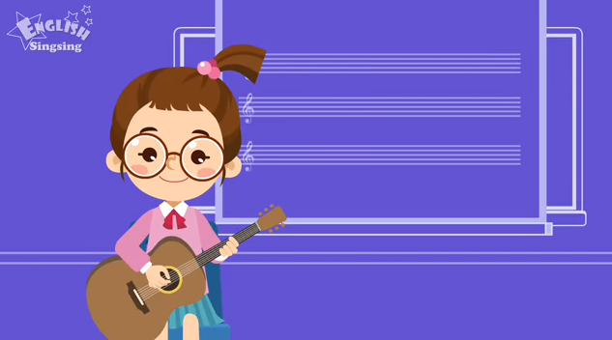

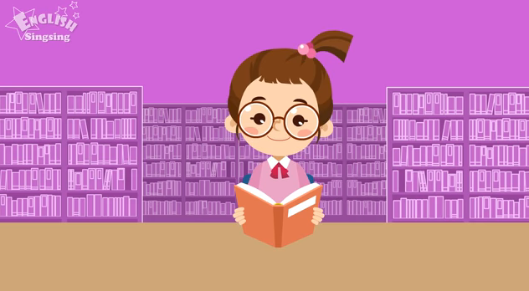

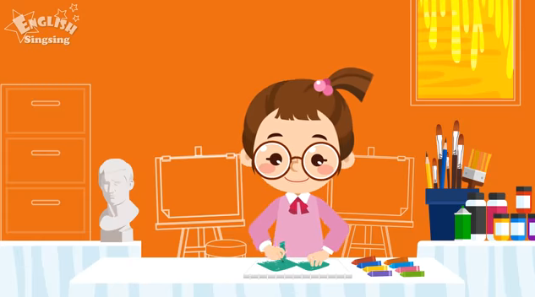

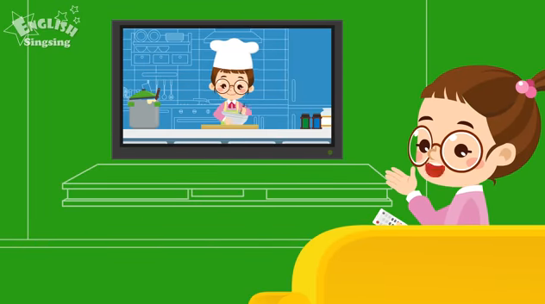



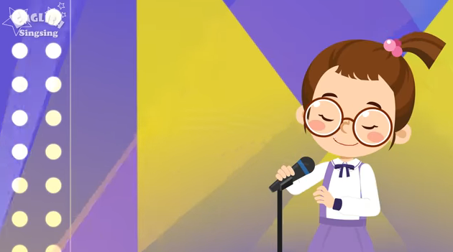

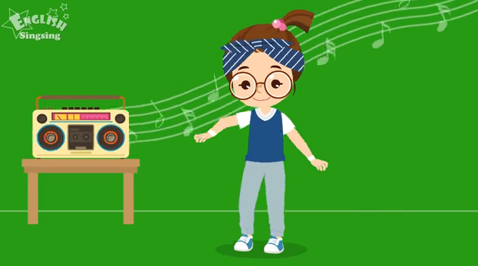

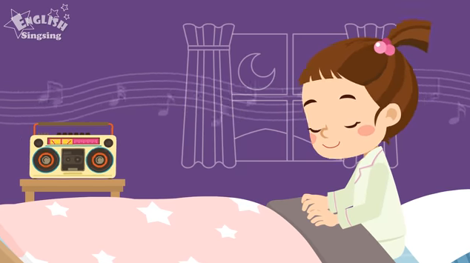

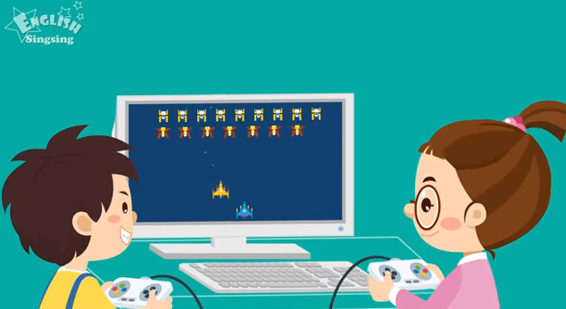

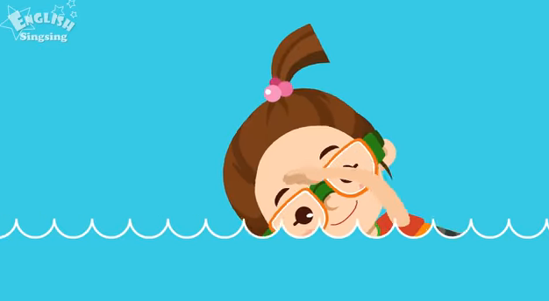

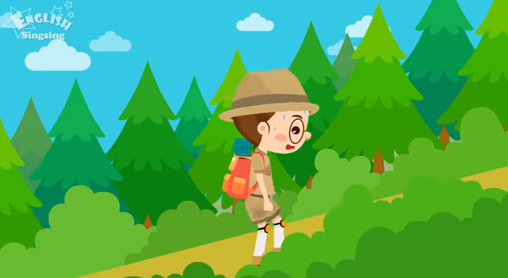

Niña tomando 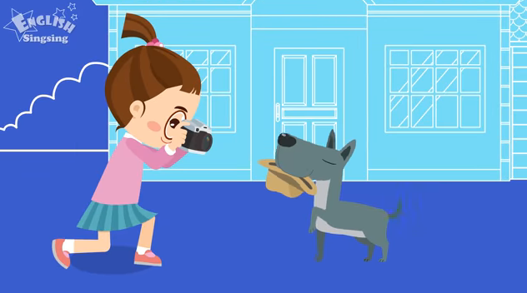

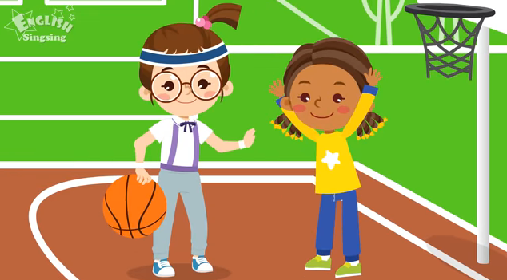

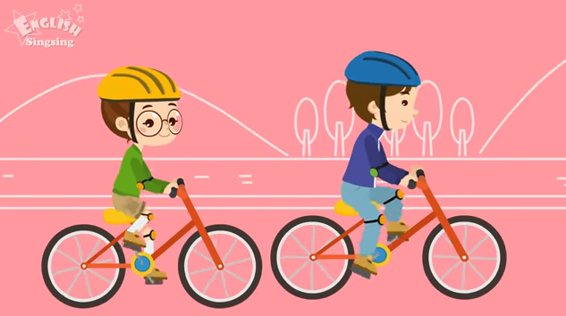

**Annex #** **3**

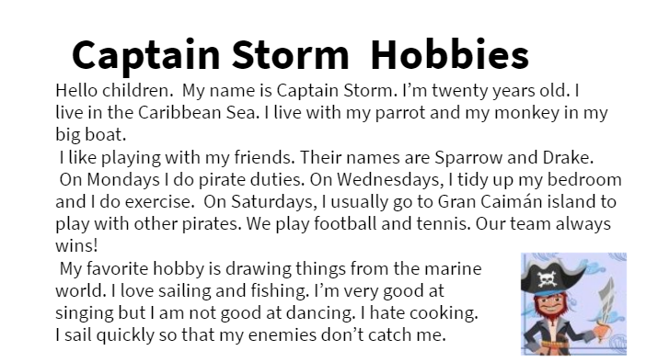

**Annex # 4**

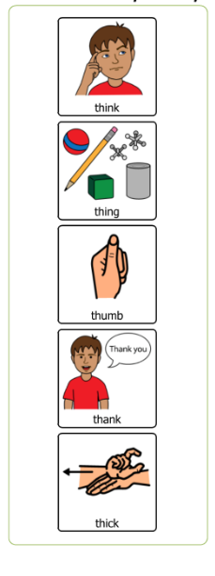

**Student B**

**Student A**

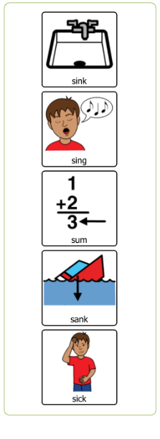

**Annex # 5**

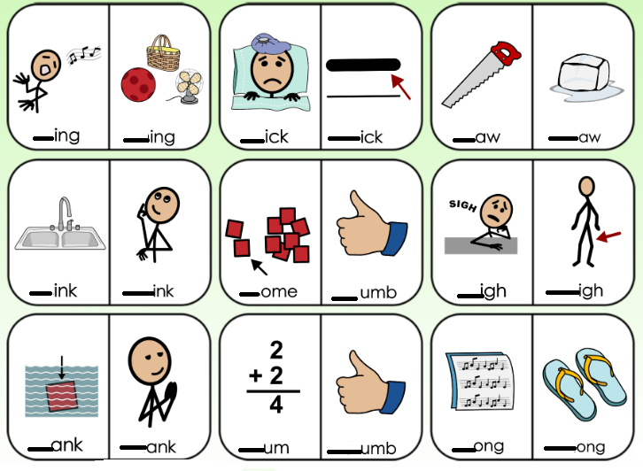

**Annex # 6**

**A: Hi, what’s your favorite hobby?**

**B: My favorite hobby is _playing video games__, and you?**

**A: I like to _Play soccer____**

**B: What do you love to do?**

**A: I love to __read books___, but I don`t like __to play the guitar_____**

**B: Me neither, I like to ____watch TV in my free time_______**

**Annex #** **7**

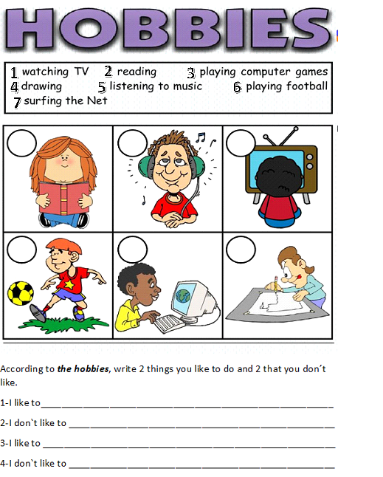

|  |  |  |  |  |  |  |  |  |  |  |  |  |  |  |
| --- | --- | --- | --- | --- | --- | --- | --- | --- | --- | --- | --- | --- | --- | --- |
| **Term:** | | **Level: Fifth Grade** | | | **Unit:** | | | | **Week:2** | | | | | |
| **Domain: Socio-interpersonal** | | | | **Scenario: Let´s Play** | | **Theme:**  Sharing Hobbies and Pastimes | | | | | | | | |
| **Enduring Understanding**: What people do for fun differs from one person to another not only because of likes and dislikes, but also because of personality, time and money. | | | | | | | | | | | | | | |
| **Essential Question:** How do people play around the world? | | | | | | | | | | | | | | |
| |  | | --- | | **Dimensions** | | **1.** **Ways of thinking ( X  )** | | **2. Ways of living in the world  ( X )** | | **3. Ways of relating with others  ( X )** | | **4. Tools for integrating with the world  ( )** | | | | | | | | | | | | | | | |
| **Learn to Know** | | | | **Learn to Do** | | **Learn to Be and Live in Community** | | | | | | | | |
| **Grammar & Sentence Frames**  Present Perfect   * How long have you been playing soccer? I started two years ago. * How long have you been playing the guitar? Since I was in second grade.   **Phonemic Awareness**  Practicing minimal pair sounds**: s / θ**  **sin/ thin, sum/ thumb, sank/ thank,**  **sink/ think, saw/ thaw**  **Vocabulary**  Sharing hobbies and pastimes  Expressions and phrases   * What do you do for fun? I am crazy about listening to rock music. * How did you choose that hobby? I am an outgoing person, I like dancing. * How long have you been collecting stamps? Three years ago.   Fun activities and hobbies  dancing, martial arts,  Descriptive adjectives  creative fascinating cheap relaxing different | | | | **Function**   * Describing hobbies and pastimes   **Discourse Markers**  Sequence adverbs-past tense  First, next, then, finally | | **Psycho-social**   * Expressing creativity when communicating owns ideas   **Socio-cultural**   * Identifying cultural differences among contexts in terms of hobbies and sports   **idioms/ phrases**   * I love to… | | | | | | | | |
| **Assessment Strategies & Evidences of learning**  (Diagnostic, formative, summative) | **Goals** | | | **Pedagogical Mediation/ Didactic Sequence** | | | | | | | | | **Time** | |
| Learner… | Learner can | | | **Connection**  **Pre-teaching**  Routine: Greetings / Prayer/ Weather conditions and the date. Checking attendance, Teacher posts the Essential Question on the board, goals, and class agenda, etc.  **Warm up**  Teacher shows pictures of some free time activities for the students to describe them. (Use pictures from **Annex 2** or **PPT1** from Week # 1)  **Activation of Prior Knowledge**  .  Students volunteer to mimic an activity or hobby for the rest of the class to guess each one for a better understanding.  **Modeling**  Teacher introduces the question structure “How long have you been ______?” He explains that it refers to the duration of the activity.  He also explains the possible answers to that question:  For example: How long have you been dancing?  Since I was 5 years old  Since 9am  For 2 hours  For three days.  Teacher displays pictures about activities and asks questions using the structure *How long have you been _______?* for students to answer.    .  **Clarification**  **Clarifying**  Teacher shows a video to explain the use of “since” and “For”. In the following link, you will watch a video about the use of “since” and “for”: <https://www.youtube.com/watch?v=WX8-MPuv5gs> (Pause the video at 3.07”)  Teacher writes the six expressions from the video:  Since 9am For three hours  Since 2015 For two hours  Since April For three months  Students answer these questions using any of the expressions:  How long have you been studying in this school? ______________  How long have you been watching TV? _________  How long have you been listening to the teacher? _____________ | | | | | | | | | 40 minutes | |
| **L2.** recognizes phrases and high frequency vocabulary related to areas of personal interest.  Indicators:  **L.2.1.** identifies phrases and high frequency vocabulary related to hobbies and fun activities by matching vocabulary with pictures or by filling in blanks.  **L.2.2.** recognizes phrases and high frequency vocabulary related to hobbies and favorite activities by circling them when heard. | **L.2.** understand phrases and high frequency vocabulary related to areas of personal interest. | | | **Connection**  **Pre-task**  Teachers introduces the goal of the lesson  Teacher shows a video to review some free time activities. In the following link, you will watch a video about free time activities: (<https://www.youtube.com/watch?v=bYeZKzHV0Hs>)  Students watch, and they will have to say two activities they like from the video. Each student shares his/her answers with a classmate and then, with the whole class.  The teacher shows the pictures of **Annex 1** from week 1 and asks students to listen and repeat as he/she makes sentences with each hobby. Example: I like to read books. I love to play basketball.  **Clarification**  **Task-rehearsal**  The teacher uses **Annex 1**, from week 2. The teacher shows the pictures with their corresponding numbers on the left column. The teacher makes a sentence for every picture first. Students listen and repeat.  The teacher says sentences at random and students show the corresponding number of the picture raising their hands and showing the corresponding number of fingers.  Students sit down in pairs. One of them makes a sentence, and the other tells him/her the number of the corresponding picture. Students switch roles.  The teacher gives students **Annex 1** from week 2 or a similar version of it. Students listen to the teacher describing her/his hobbies. Students write the corresponding number in the cells on the right column. This is the script of the teacher’s hobbies.   1. I love cooking. 2. I love taking photographs. 3. I love listening to music. 4. I love singing in front of people. 5. I like reading books. 6. I like playing the guitar. 7. I love playing basketball. 8. I enjoy riding my bike. 9. I like watching TV. 10. I love playing games with my friends.   Students sit down in pairs and compare answers. Then, the teacher calls for volunteers to go to the board and write down the numbers on the board.  **Application/building up**  **Task completion**  Students watch a video about two people talking about their interests**.** In the following link, you will watch a video about interests: **(**<https://www.youtube.com/watch?v=yOJkygDGWvU>)  **Task**: Your English teacher has asked you to watch a short video in which two people talk about their interests. Your teacher asks you to complete the chart below with the corresponding information to talk about it in class.   |  |  |  |  | | --- | --- | --- | --- | | empty | **Favorite activity** | **How long** | **Another activity they like** | | **Man** | empty | empty | empty | | **Woman** | empty | empty | empty |   **Collaboration**  **Task assessment**  Students sit down in pairs and compare answers. The teacher walks around the classroom with an instrument to evaluate the students’ performance. | | | | | | | | | 40 minutes | |
| **R2.** comprehends reading, analyzes and enjoys texts.  Indicators:  **R.2.1.** responds to questions completing diagrams and/or maps about people´s hobbies and favorite pastimes.  **R.2.2.** examines the main points of text about people´s hobbies and favorite pastimes for making decisions and recommendations.  **R.2.3.** connects personal feelings and experiences with the text read. | **R.2.** comprehend readings, analyze and enjoy texts. | | | **Connection**  **Pre-task**  **Teacher introduces the goal of the lesson**  In order to review the vocabulary, by using pictures, the teacher will read statements about hobbies and pastimes and students will show if they agree or disagree with the statement by using their thumbs up or down.  Teacher shows and reads the statements from the board:  I like dancing.  I love to sleep.  I don´t like going to the beach.  My favorite hobby is playing computer games.  Teacher calls different students to respond the question *What do you do for fun?*  Students will mention the activities they like.  **Clarification**  **Task-rehearsal**  Teacher gives students a worksheet with the paragraph in **Annex #2 from week 2.** Students answer the questions about the reading by completing the table.  Niño sonriendo con burbuja de texto que contiene información sobre lo que le gusta y no le gusta hacer en su tiempo libre.  This is an alternative version of the text in case any student or teacher has trouble reading from the picture:  Hi there! I’m Julian. I’m 10. I like reading comics and takin photos, but I don’t like shopping, although I go shopping with my mum on Saturdays.  At the weekends, I like roller-skating with my brother, John and my dad.  In the evening, before going to bed, I like talking to friends by Skype.  My brother, John, likes collecting stickers, but I don’t like it.  What does Julian like to do in his free time? What doesn’t he like? Complete the chart below. Write an X in the corresponding cell.   |  |  |  | | --- | --- | --- | | **JULIAN** | What he likes | What he doesn’t like | | Reading comics | empty | empty | | Going shopping | empty | empty | | Roller-skating | empty | empty | | Talking to friends | empty | empty | | Collecting stickers | empty | empty |   The teacher calls for volunteers to go to the blackboard and write down the answers.  **Application/building up**  **Task completion**  Students read the paragraph about Julian´s favorite activities again. They read the sentences and do the Tue-False exercise (See **Annex 3**). If possible, students can click on the following link to do the exercise online. In the following link, you will find the reading exercise online: <https://www.liveworksheets.com/ma1901603ig>  Based on what Julian likes to do the most, what 2 types of hobbies would you recommend him to practice with you in your free time?  Teacher checks the answers and gives feedback.  **Collaboration**  **Task assessment**  Students read the text and indicate if they like Julian´s activities by writing a check mark according to their own interests in the following chart: (see **annex 4**)   |  |  |  | | --- | --- | --- | | THINGS I LIKE DOING | | | | **ME** | Smiley - Wikipedia, la enciclopedia libre  I like… | Free Sad Face Icon, Symbol. PNG, SVG Download.  I don’t like… | | Reading comics |  |  | | Going shopping |  |  | | Roller-skating |  |  | | Talking to friends |  |  | | Collecting stickers |  |  |   Students practice in pairs asking each other the following questions:  Do you like reading comics?  Do you like going shopping?  Do you like ___? | | | | | | | | | 40 minutes | |
| **R.P.A.1.** produces the 44 phonemes with verbal modeling and visual cues and practices minimal pair sounds: s / θ sin/ thin.  INDICATORS  **R.P.A.1.2**. recognizes the pronunciation of minimal pair sounds: s / θ as they appear in list of words or sentences.  **R.P.A.1.3**.reads words and sentences that contain the minimal pair sounds: s / θ sin/ thin correctly | **R.P.A.1.** produce the 44 phonemes of English with verbal modeling and visual cues. | | | **Connection**  **Pre-task**  Teachers introduces the goal of the lesson  Students watch the video about minimal pairs /Ɵ/ /s/. Students pay attention to the pronunciation and to the vocabulary presented in the video. In the following link, you will find a video about the pronunciation of /Ɵ/ and /s/: [**https://youtu.be/coI1jElTEls**](https://youtu.be/coI1jElTEls)  **Speech with Jenn**  **Minimal Pairs th/s**  The teacher will give some examples of words pronounce with /Ɵ/ and /s/. Teacher demonstrates how to produce the sound. Students are asked to repeat.  /s/  Sings  Sick  mouse  /Ɵ/  Things  Thick  mouth  **Clarification**  **Task-rehearsal**  Students get mini flash-cards with some pictures related to these minimal pairs (**Annex 5**).  Students repeat after the teacher the words in the different pictures.  Ilustraciones a color de un serrucho, n cubo de hielo que se derrite, de un barco que se hunde, uy un niño en dibulo de palitos agradeciendo a otro.  The teacher pronounces each word at random. Students will number the words in the order they hear them.  Students read the words in pairs: student A reads and student B identifies the word heard.  Teacher checks and clarifies.  **Application/building up**  **Task completion**  Teacher shows different pictures with words (**Annex 5**), and students pronounce them correctly.  Students are called individually to pronounce the word the teacher shows.  After students answer, teacher repeats the word to clarify any students’ doubts.  Students read some sentences and pronounce the minimal pair sounds /s/ /Ɵ/ correctly. Then, they underline them and place the minimal pairs found in the sentences in the corresponding column by using a check mark.   |  |  |  | | --- | --- | --- | | MINIMAL PAIRS | | | |  | /Ɵ/ | /s/ | | Thank you very much. |  |  | | The boat sank. |  |  | | Open your mouth. |  |  | | The mouse is ugly. |  |  | | I like many things. |  |  | | My mother is sick. |  |  |   **Collaboration**  **Task assessment**  Provide peer and teacher’s feedback after completing main task. | | | | | | | | | 40 minutes | |
| **SI.1.** asks others simple questions concerning their homes (village/town) or their interests (e.g., Where do you live? What do you like?).  INDICATOR  **SI.1. 1.** asks others simple questions concerning their homes (village/town) or their interests (e.g., Where do you live? What do you like?) in an informal exchange. | **SI.1.** ask others simple questions concerning their homes (village/town) or their interests (e.g., Where do you live? What do you like?). | | | **Connection**  **Pre-task**  Teachers introduces the goal of the lesson.  The teacher tells students that the school is organizing different school clubs. The clubs will be organized according to students´ preferences, so he/she will ask some of them a few questions. The teacher draws a table on the board with the names of some students. María is the first name on the list.  **Teacher**: Hello María! What do you do for fun?  **María**: I´m crazy about dancing.  **Teacher**: How long have you been dancing?  **María**: I have been dancing for three years. I love it.  **Teacher**: Sounds interesting! Thank you! See you.  After asking the questions, the teacher writes down the underlined information in the table.   |  |  |  | | --- | --- | --- | | Classmate | Hobby | Time | | María | dancing | Three years | |  |  |  |   Students are introduced to some descriptive words for hobbies and pastimes. Students are taught that these descriptions may match more than one hobby. That will depend on their own opinion.   |  |  | | --- | --- | | **HOBBIES** | **DESCRIPTIVE PHRASE** | | Dancing  Listening to rock music  Collecting stamps  Playing soccer  Playing video games  Cycling  other | It´s funny  It´s fascinating  It´s relaxing  It´s cheap  It´s different  It´s easy.  It´s exciting |   Teacher clarifies the meaning and pronunciation.  **Clarification**  **Task-rehearsal**  In pairs, students practice asking and answering questions about hobbies just like in the example shared by the teacher above.  **Application/building up**  **Task completion**  To motivate your group, the homeroom teacher wants to organize some clubs for the students. The teacher has chosen you to go around the class and ask your classmates about their hobbies. Prepare a simple table like the one below with the names of at least 8 classmates. Stand up and walk around the classroom asking them questions about their hobbies and how long they have practiced them.   |  |  |  | | --- | --- | --- | | Classmate | Hobby | Time | |  |  |  | |  |  |  |   The teacher walks around the classroom to listen to students participating and evaluate their performance.  When all of them are finished, students report in a simple way about what they found out.  **Collaboration**  **Task assessment**  By throwing a ball to a classmate, students make questions about any of the different hobbies studied in the lesson. Students will answer using any of the descriptive phrases.  Example:  Ana, what do you do for fun?  I´m crazy about cycling. I think it´s relaxing  Teacher monitors and clarifies  **Post Task**  Ilustración de un círculo con varias ilustraciones de hobbies con un spinner en el medio. Students can make a **“Hobbies Fidget spinner game”.** On a piece of paperboard students make a spinner with as many hobbies as they want (they can use the same they have been studying). Cut a small arrow and place it in the middle of the spinner. Ready to play.  Look at the example: | | | | | | | | | 40 minutes | |
| **Integrated Mini-Project** | | | | | | | | | | | | | **Time** | |
| * Phase: _______ **Planning** and creating **collaboratively** a mini-book or a video-book where each learner describes personal interests and hobbies and future plans **using** sentence frames and unit vocabulary to **report it in oral and written way** to the class and family. **Participating** in co-assessment using technically designed instruments. | | | | | | | | | | | | |  | |
| **Reflective Teaching** | | | | | | | | | | | | | | |
| What worked well | | | What didn’t work well | | | | How to improve | | | | | | | |
| **Enduring Understanding Reflection** | | | | | | | | | | | | | | |
|  | | | | | | | | | | | | | | |
| **Learner Self-Assessment** | | | | | | | | | | | | | |
| ***I can…*** | | | | | | | | ***C:\Users\mcastilloh\Downloads\descarga.jpg***  ***No achieved yet***  (Learner cannot achieve the task) | | ***C:\Users\mcastilloh\Downloads\Grinning-Face-with-Smiling-Eyes.png***  ***In progress***  (Learner can achieve the task with some difficulty and needs improvement) | ***Resultado de imagen para happy emoji***  ***Achieved***  (Learner can achieve the task without any difficulty). | | |
| identify phrases and high frequency vocabulary related to hobbies and fun activities by matching vocabulary with pictures or by filling in blanks. | | | | | | | |  | |  | |  | |
| recognize phrases and high frequency vocabulary related to hobbies and favorite activities by circling them when heard. | | | | | | | |  | |  | |  | |
| respond to questions completing diagrams and/or maps about people´s hobbies and favorite pastimes. | | | | | | | |  | |  | |  | |
| examine the main points of text about people´s hobbies and favorite pastimes for making decisions and recommendations. | | | | | | | |  | |  | |  | |
| connect personal feelings and experiences with the text read. | | | | | | | |  | |  | |  | |
| recognize the pronunciation of minimal pair sounds: s / θ as they appear in list of words or sentences. | | | | | | | |  | |  | |  | |
| read words and sentences that contain the minimal pair sounds: s / θ sin/ thin correctly | | | | | | | |  | |  | |  | |
| ask others simple questions concerning their homes (village/town) or their interests (e.g., Where do you live? What do you like?) in an informal exchange. | | | | | | | |  | |  | |  | |

**Annex # 1**

|  |  |  |
| --- | --- | --- |
| 1 |  |  |
| 2 |  |  |
| 3 |  |  |
| 4 |  |  |
| 5 |  |  |
| 6 |  |  |
| 7 |  |  |
| 8 |  |  |
| 9 |  |  |
| 10 |  |  |

**Annex # 2**

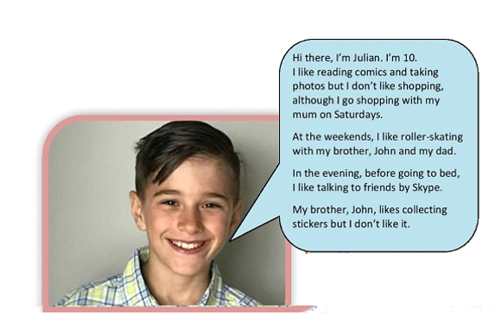

**Annex # 3**

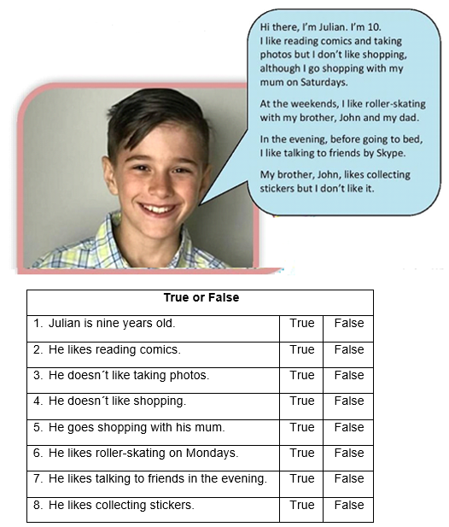

**Annex # 4**

|  |  |  |
| --- | --- | --- |
| THINGS WE LIKE DOING | | |
| **ME** | Smiley - Wikipedia, la enciclopedia libre | Free Sad Face Icon, Symbol. PNG, SVG Download. |
| Reading comics |  |  |
| Going shopping |  |  |
| Roller-skating |  |  |
| Talking to friends |  |  |
| Collecting stickers |  |  |

**Annex # 5**

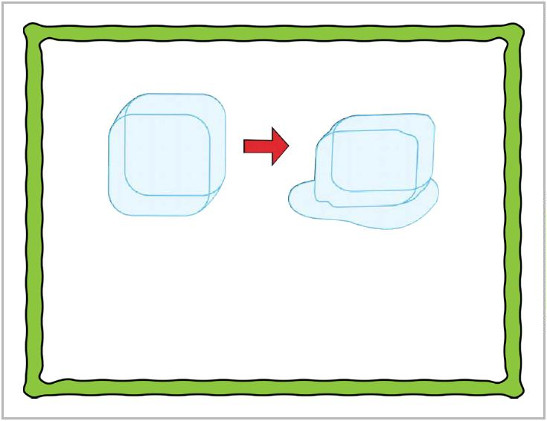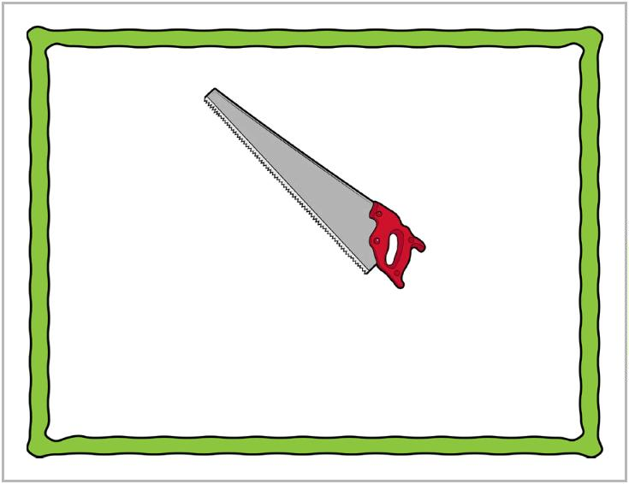

saw

thaw

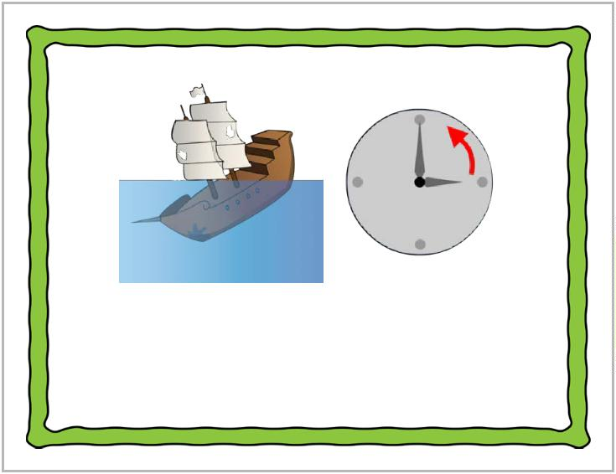

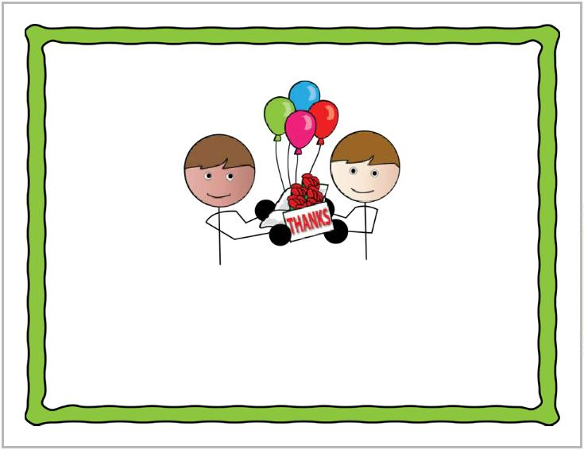

sank

thank

sink

think

sick

thick

sings

things

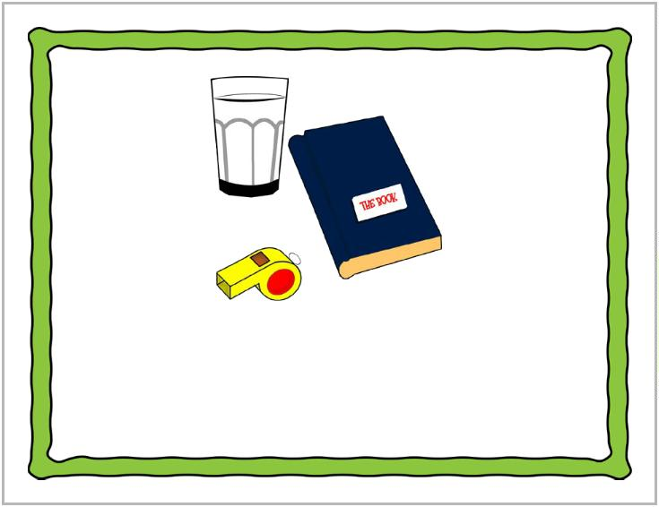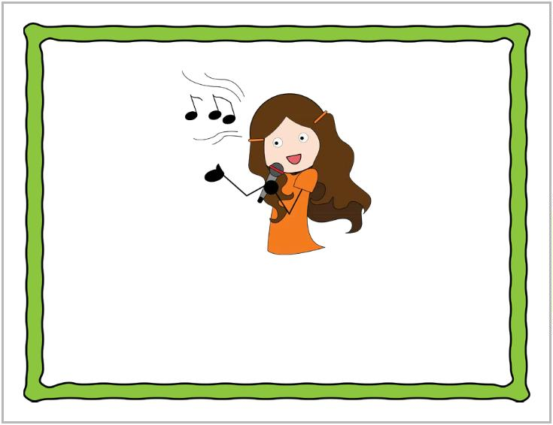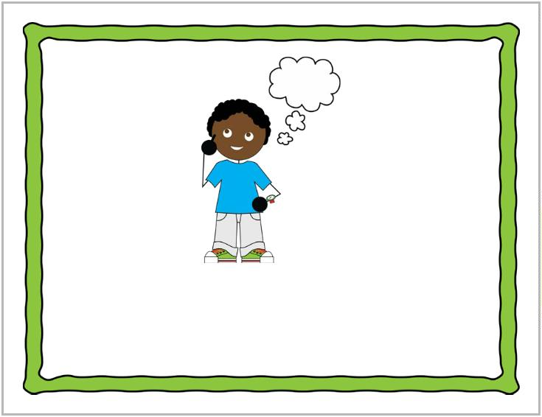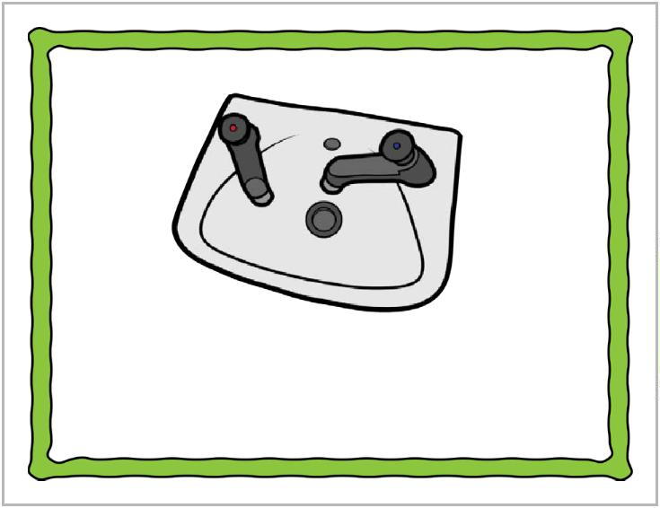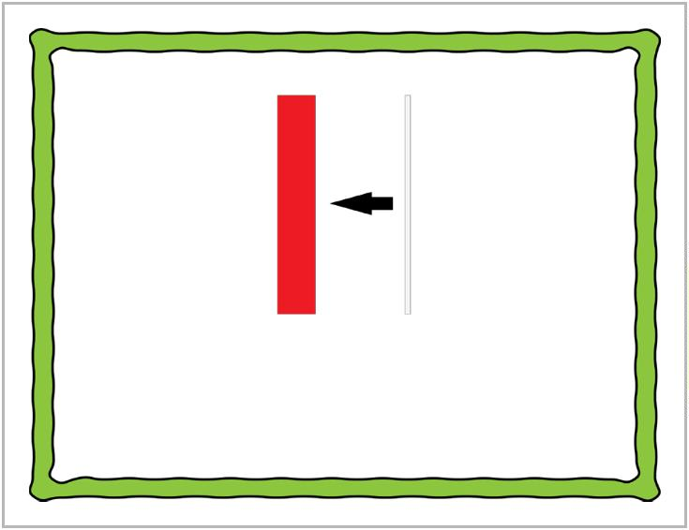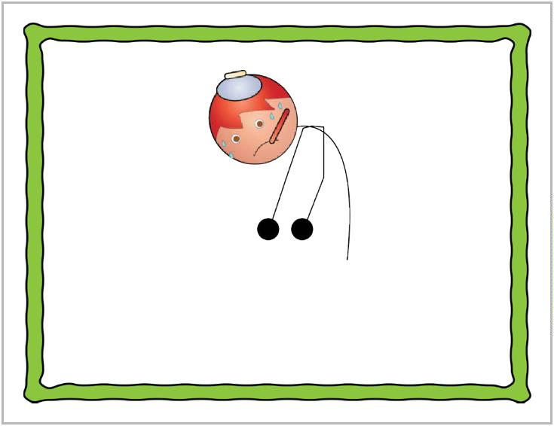

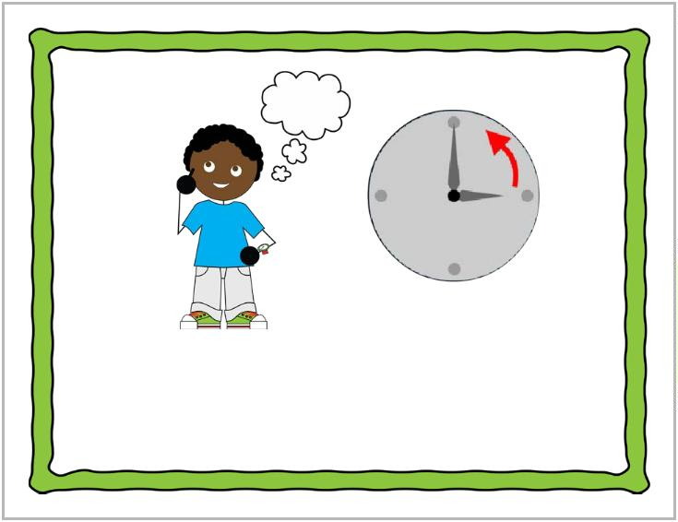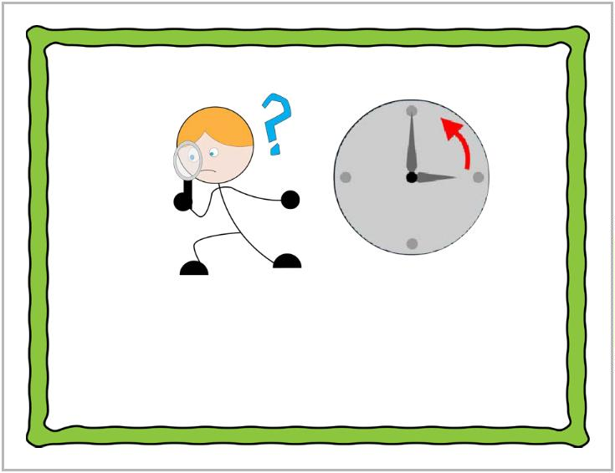

path

pass

mouth

mouse

sought thought

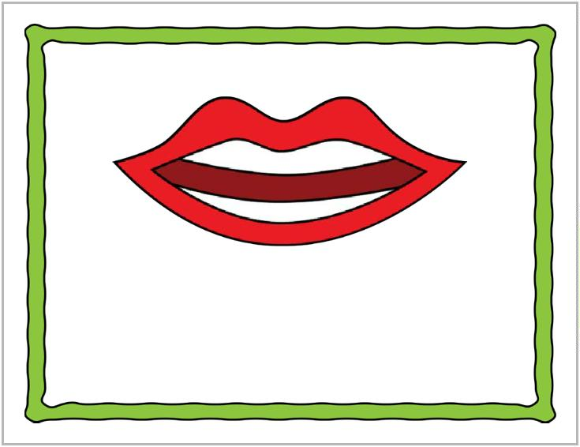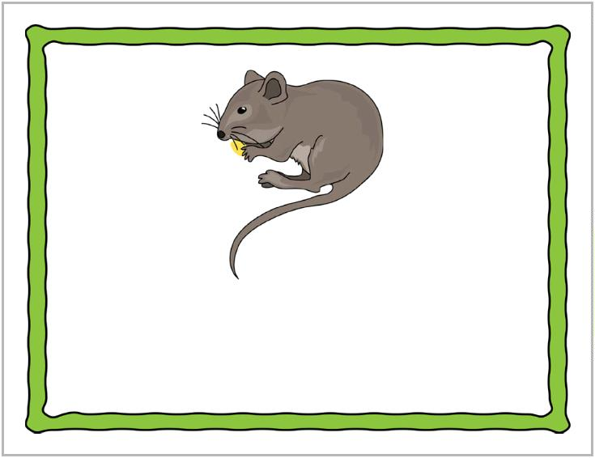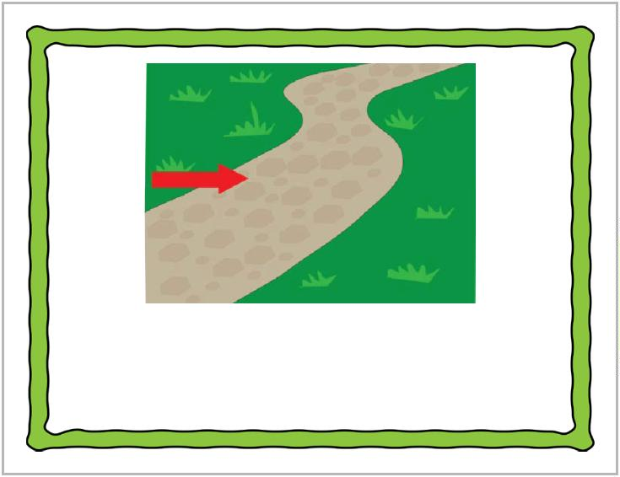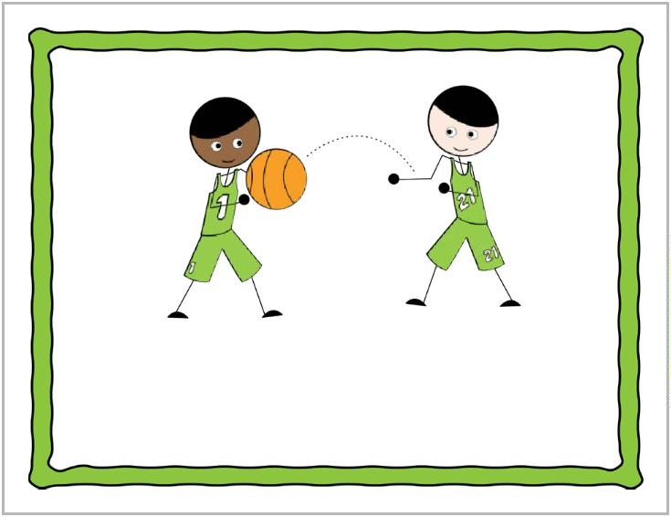

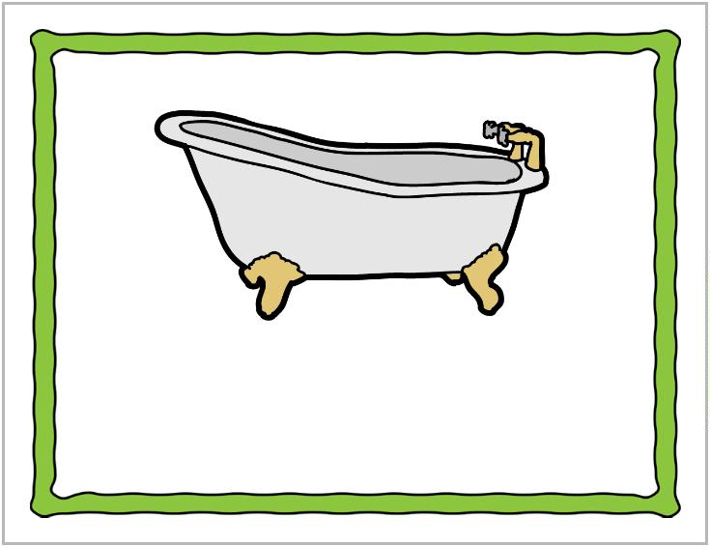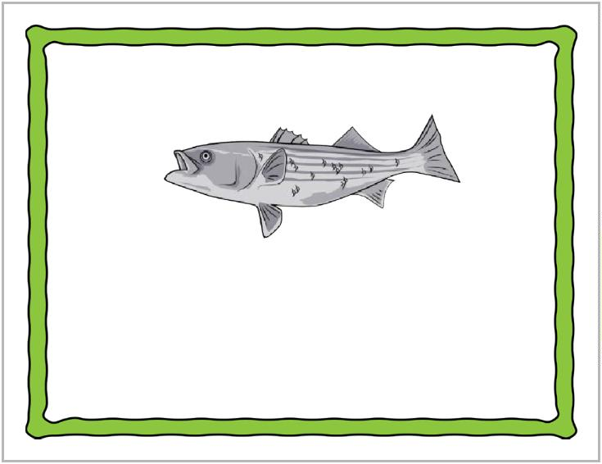

bass

bath

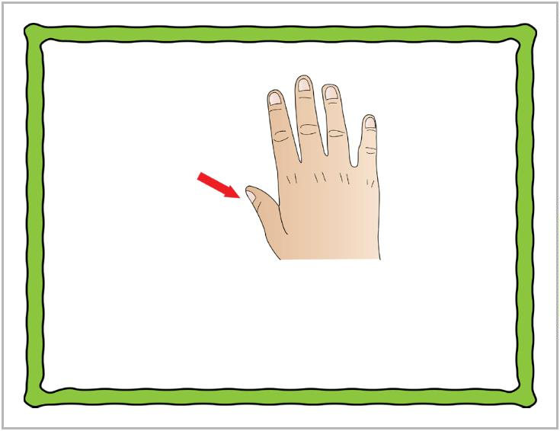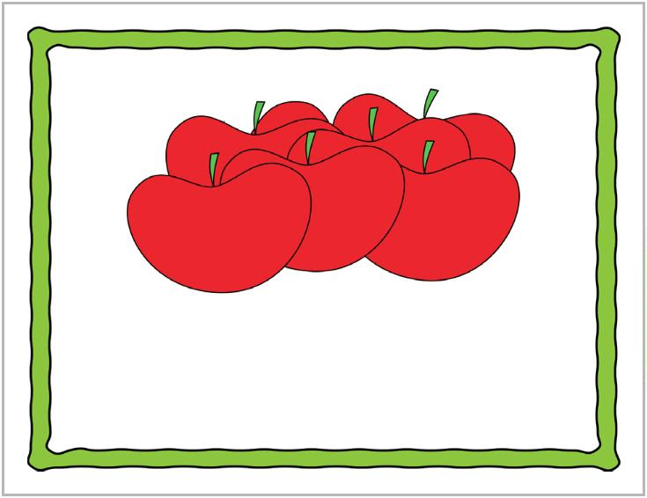

thumb

some

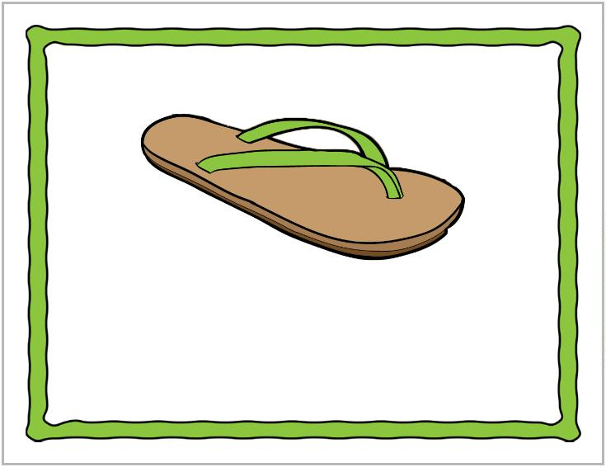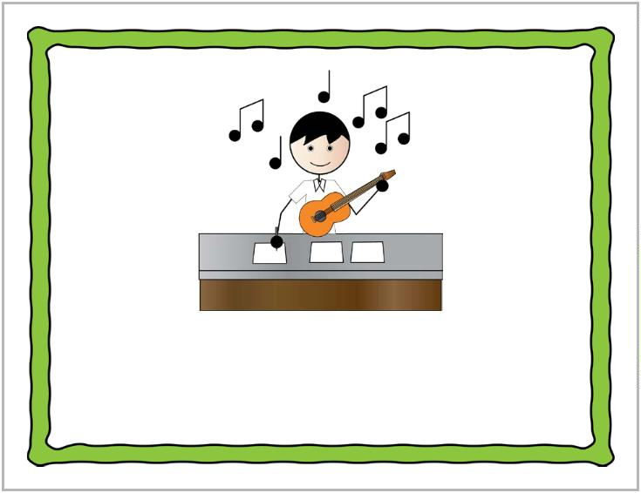

song

thong

|  |  |  |  |  |  |  |  |  |  |
| --- | --- | --- | --- | --- | --- | --- | --- | --- | --- |
| **Term:** | | **Level: Fifth Grade** | | | **Unit: 6** | | | **Week:3** | |
| **Domain: Socio-interpersonal** | | | | **Scenario: Let´s Play** | | **Theme:**  Do you have Plans for the Weekend? | | | |
| **Enduring Understanding**: What people do for fun differs from one person to another not only because of likes and dislikes, but also because of personality, time and money. | | | | | | | | | |
| **Essential Question:** How do people play around the world? | | | | | | | | | |
| |  | | --- | | **Dimensions** | | **1.** **Ways of thinking ( X  )** | | **2. Ways of living in the world  ( X )** | | **3. Ways of relating with others  ( X )** | | **4. Tools for integrating with the world  ( )** | | | | | | | | | | |
| **Learn to Know** | | | | **Learn to Do** | | **Learn to Be and Live in Community** | | | |
| **Grammar & Sentence Frames**   * Future with going to/will   I’m going to play soccer with my friends tomorrow.  I will go skating this weekend.  **Phonemic Awareness**  Distinguishing spoken rhyming words from non-rhyming words. (e.g., run, sun versus run, man, etc).  **Vocabulary**  Do you have plans for the weekend?  Expressions and phrases   * Are you busy on Sunday? * Do you want to hang out? * I am going to play soccer with Mike * I will sing karaoke. * She will ride on bike with her friends.   I like to____  I want to ______  I plan to______  I´m going to ____  Fun activities and hobbies  Playing the violin, skateboarding, snorkeling | | | | **Function**   * Describing future plans related to hobbies   **Discourse Markers**  Sequence adverbs-past tense  First, next, then, finally | | **Psycho-social**   * Working cooperatively with others   **Socio-cultural**   * Comparing traditional games in CR and around the world   **Idioms/ phrases**   * You are barking up the wrong tree= you´ve got the wrong person or idea. | | | |
| **Assessment Strategies & Evidences of learning**  (Diagnostic, formative, summative) | **Goals** | | | **Pedagogical Mediation/ Didactic Sequence** | | | | | **Time** |
| Learner… | Learner can | | | **Pre-teaching**  Teacher greets students and introduces the Essential Question and goals for the day.  **Warm up**  Students watch a video about the way children play around the World.  Students are asked to mention the games that they have played or that they recognize in the video.  The teacher reads the quote that appears at the end of the video, and she lets them know her appreciation and respect to their playing time. In the following link, you will find a video about the way children play around the World: <https://www.youtube.com/watch?v=spVsC4xBYac>  This is the quote at the end of the video:  “Play is often talked about as if it were a relief from serious learning. But for children play is serious learning. Play is really the work of childhood.”  Fred Rogers  Option 2 for warm up: Storytime. Students listen to the story in the next video, and compare some of the games to Costa Rican traditional games. For example: Sea, moon, sky/ “Mar y tierra”. In the following link, you will find a video about Children's Games Around the World: <https://www.youtube.com/watch?v=RjZ5aPpq98c>  **Activation of Prior Knowledge**  Students watch the video: Popular Childhood Games Around the World. They are asked to look for the names in English of the games they recognize. In the following link, you will find a video about popular childhood games around the world: <https://www.youtube.com/watch?v=teKyQ79GbXk>  Students report some of the game names mentioned in the video. Teachers writes those names on the board:  Tag, hide and seek, hopscotch, marbles, hand-clap, musical chairs, freeze dance, telephone, tug of war, green light, paper airplane, catch, blind man buff, hot or cold, spy, jump rope, rock paper scissors, Tic tac toe.  **Modeling**  Teacher reviews or introduces how to form sentences to talk about plans.  I´m going to play video games this weekend.  I´m going to play hide and seek.  I will visit Alajuela this weekend.  I will play soccer this weekend.  See more examples in **Annex 1**.  **Clarifying**  Students will express future plans by completing the sentence frames from a practice. See annex 2.  Practice #1  Complete each sentence about plans for the future by using “will” and the verb in parentheses.  Example: Fanny will **play** video games this weekend. (play)   1. Gwen __________________________ early tonight. (watch TV) 2. Francis ________________________ soccer with his friends tomorrow. (play) 3. I _________________________ in the river tomorrow.” (swim) 4. Mrs. Susan ___________________________ a book this weekend. (read)   Practice #2  Complete each sentence about plans for the future by using (am-is-are) +going to + verb in parentheses.  Example: Bob and Cathy are going to visit the zoo tomorrow (visit)   1. Julie __________________________ shopping next Saturday. (go) 2. I ________________________ in the swimming pool at ten o’clock. (swim) 3. Mr. Castro _________________________ his bike tomorrow. (ride) 4. My friend ___________________________ at a restaurant tonight. (eat)   Teacher and students check the exercises together. | | | | | 40 minutes |
| **SI.1.** asks others simple questions concerning their homes (village/town) or their interests (e.g., Where do you live? What do you like?).  Indicator:  **SI.1. 1.** asks others simple questions concerning their homes (village/town) or their interests (e.g., Where do you live? What do you like?) in an informal exchange. | **SI.1.** ask others simple questions concerning their homes (village/town) or their interests (e.g. Where do you live? What do you like?). | | | **Pre-task**  Teacher introduces the goal of the lesson  The teacher writes/projects the following example of a conversation on the board:  Teacher: Hi (name of student)! What do you like to do in your free time?  Student: ____________________________  Teacher: And what are you going to do this weekend?  Student: On Saturday, I’m going to….. On Sunday, I’m going to….(note: if possible, ask the student to use sequence adverbs)  Teacher: Do you want to hang out? Let’s go (activity) this weekend.  Student: (accepts or refuses invitation)  The teacher asks for one volunteer to practice the conversation. As the teacher and student practice the conversation, the teacher writes downs some of the student’s answers on the board.  **Task-rehearsal**  Next, the teacher reads the questions and asks students to repeat them.  The teacher divides the group into two. One group will read the teacher’s part and the other group will read the student’s part.  The teacher asks students to sit down in pairs and brainstorm activities that both of them like to do and will do during the weekend.  **Task**: You want to hang out with your friend this weekend. Find out what he/she likes to do and what he/she is going to do this weekend. Invite him/her to do something together. Use any of the following questions:  What do you like to do in your free time?  What are you going to do this weekend?  Students practice switching roles until they are fluent enough.  **Task completion**  Teacher divides the class in small teams(3/4 students) and gives them the following task.  **Team task**: You decided to go with your friend to the Town’s Fair. There, you would like to make new friends. Strike up one or two short conversations with people you would like to know. You have to greet them. Tell your name. Ask for their names. Tell where you live. Ask them about the place they live and about what they like to do in their free time.  Be ready to present. Pairs of students who finish first, call the teacher and present their conversation for her/him. Some volunteers will present the conversation in front of the class.  The teacher gives students feedback after the presentations or gives them some extra practice to reinforce key aspects.  **Task assessment**  While listening to music, students will move around the classroom. Once the music stops, they will find a partner and ask the questions practiced in the conversation. Students will switch partners several times.  Teacher monitors and gives feedback and clarifies if necessary. | | | | | 40 minutes |
| **R.P.A.2.** distinguishes spoken rhyming words from non-rhyming words. (e.g., run, sun versus run, man, etc).  INDICATORS:  **R.P.A.2.1.** recognizes spoken rhyming words from non-rhyming words by reading them aloud.  **R.P.A.2.2.** classifies spoken rhyming words from non-rhyming words. (e.g., run, sun versus run, man, etc.) by circling the rhyming words. | **R.P.A .2.** distinguish spoke rhyming words from non-rhyming words. (e.g., run, sun versus run, man, etc). | | | **Pre-task**  Teacher introduces the goal of the lesson.  Students listen to the song: **Rhyming Words For Kindergartners** to approach the new topic. In the following link, you will find a video with the song rhyming words for kindergartners: [**https://youtu.be/EuAjgo6NSVM**](https://youtu.be/EuAjgo6NSVM)  Teacher explains the meaning of rhyming words by writing some examples from the video and explains why those words rhyme.  Rhyming words  Cat –bat- hat – rat  Fan – pan – can – man  Teacher explains the differences between the Rhyming Words and Non-rhyming Words  Rhyming Words are those words that have the same ending sounds.  For example: run/sun- check/neck  Non- rhyming words are words that have different ending sounds although they can sound similar.  For example: run/man- dog/duck    **Task-rehearsal**  Teacher asks students to say a pair of rhyming words using the words from the video. For example, students will say: bat/hat or dad/sad.  Teacher asks students to say a pair of non-rhyming words using the words from the video. For example, students will say: map/men dad/cat  In order to do these activities, the teacher will show the following list:  at cat, bat, hat, rat  an fan, pan, can, man  ap cap, map, nap, tap  ad Dad, sad, pad, lad  en pen, men, hen, ten)  Students will work in pairs saying rhyming words and non-rhyming words by using these other words. Teacher will monitor the activity and clarifying.  The teacher delivers strips of paper where students draw and write the name of a **Rhyming Word and** **Non- rhyming word** based on the given picture and the word.   |  |  |  | | --- | --- | --- | | **Sad**  Kleurplaat verdrietig | Emociones dibujos, Actividades sentimientos,  Emociones preescolares | **Rhyming Word**  mad | **Non- rhyming word**  **mom** |  |  |  |  | | --- | --- | --- | | **Jeep** | **Rhyming Word** | **Non- rhyming word** |  |  |  |  | | --- | --- | --- | | **Hen** | **Rhyming Word** | **Non- rhyming word** |  |  |  |  | | --- | --- | --- | | **Box** | **Rhyming Word** | **Non- rhyming word** |  |  |  |  | | --- | --- | --- | | **Clam** | **Rhyming Word** | **Non- rhyming word** |   **Task completion**  Then, the teacher shows pairs of flashcards and students classify them as **Rhyming Words** or **Non- rhyming words.**   |  |  |  |  | | --- | --- | --- | --- | | **empty** | **empty** | **Rhyming Word** | **Non- rhyming word** | | jeep | sheep |  |  | | cat | clam |  |  |   **Task assessment**  Students check their answers in pairs as a form of peer assessment, and finally the teacher provides group feedback based on their performance in the task completion.  **Post task**  Teacher reads a series of words for students to identify the one that doesn´t rhyme by circling the picture. See **annex 3**   |  |  | | --- | --- | | **Odd one Out**  **Instructions:** Listen carefully to the teacher and cross out the one that does not have the same rhyme. | | | **/-eep/**  beep | Cuatro ilustraciones pequeñas: una niña durmiendo, una oveja, un jeep y un carro. | | **/-at/**  bat | Cuatro ilustraciones: una campana, un gato, una alfombra y un ratón. | | **/-op/**  **top** | Cuatro ilustraciones: un hacha, un palopiso, una aguja entrando en un globo y un termometro. | | **/ -ap/**  tap | Cuatro ilustraciones: un mapa, un bocin, una mano chasqueando dedos y una gorra. | | **/ -am/**  Sam | Cuatro ilustraciones: un baso de mermelada, una almeja, el ala de un cisne y un carnero. |   Answer Key   1. car 2. bell 3. hot 4. beep 5. wing   Students identify the one that doesn´t rhyme by circling the picture. See **annex 3** | | | | | 40 minutes |
| **SP.2.** talks about a familiar topic in a short presentation.  Indicators:  **SP.2.1.** brainstorms main ideas about hobbies and future plans.  **SP.2.2.** speaks with simple phrases and sentences to describe favorite hobbies and future plans for the weekend to a partner or friend.  **SP.2.3.** talks about his favorite hobbies and future plans in a short presentation. | **SP.2.** Talk about a familiar topic in a short presentation. | | | **Pre-task**  Teacher introduces the goal of the lesson.  The teacher shows students a series of pictures about different activities that he/she will do on the weekend. As he/she speaks, he/she shows the different pictures.  Example: Hi! I hope you are doing fine. On Saturday, I’m going to the beach. I’m going to playa Herradura. I love going to the beach. First, I’m going to swim in the ocean. Then, I’m going to play soccer with my cousins. Later, ….  **Task-rehearsal**  The teacher shares the task with the students.  **Task**: You have a friend in another country. He/She is learning about you and Costa Rica. You want to tell him/her about your plans for the weekend. You are going to record a short video to send him/her (in case students do not have access to technology in the classroom, they will make a face-to-face presentation to a partner). Include pictures in your presentation.  The teacher asks students to brainstorm ideas about their plans for the weekend related to hobbies.  Students practice individually using simple phrases and sentences to describe their plans for the weekend.  Students record their videos and share it with a partner for feedback(in case students have access to technology).  **Task completion**  Students who finish first their video recordings will show them to the whole class for feedback before sending it to their friend. Those who do not have video recordings will present it to the whole class.  **Task assessment**  Students make pairs. Each student takes a turn presenting the video recording or the oral presentation, and the partner listens and provides feedback using the following checklits.   |  |  |  |  | | --- | --- | --- | --- | | My classmate can | Achieved  ***Carita feliz.***  (Learner can achieve the task without any difficulty). | ***Carita insatisfecha.***In process  (Learner can achieve the task with some difficulty and needs improvement) | Not achieved yet  ***Carita triste.***  (Learner cannot achieve the task) | | speak with simple phrases and sentences to describe favorite hobbies and future plans. |  |  |  | | talk about his/her favorite hobbies and future plans. |  |  |  | | use pictures to support his/her ideas. |  |  |  | | | | | | 40 minutes |
| **W.1.** Composes short texts expressing wants and preferences.  Indicators:  **W.1.1.** brainstorms main ideas about preferences and future plans as a form of pre-writing.  **W.1.2.**makes an outline to organize the main ideas about preferences and future plans using phrases and simple sentences.  **W.1.3.** makes a draft of text by writing complete sentences for each main idea.  **W.1.4.** edits a text by checking grammar, spelling, punctuation and capitalization to make sure it is well-written. | **W.1.** compose short sentences expressing wants and preferences. | | | **Pre-task**  Teacher introduces the goal of the lesson.  The teacher can use the following video as a reference and can play parts of it during the lesson to illustrate every step of the writing process for the students. The video is aligned with the indicators for this assessment strategy. In the following link, you will find a video about how to write a paragraph: <https://www.youtube.com/watch?v=lMRTtUrSFOc>  The teacher tells students that he/she is very happy because he/she has plans for the weekend.  The teacher makes a short simple oral presentation for the group. After that, the teacher explains that the school is going to organize some clubs for students. They are asking students to write a short paragraph describing what they like to do. The teacher pretends to be recalling what he/she just said. He/She writes a title for his paragraph. Then, he/she writes a simple sample paragraph as a model. When he/she finishes writing down the paragraph, he/she calls students attention to important aspects such as: introduction, details and concluding sentence, punctuation, grammar, capitalization and spelling.  The teacher lets students know that this is similar to what they will do in class.  **Task-rehearsal**  Teacher projects the first part of the video about brainstorming for students to do the same. Students are asked to brainstorm ideas (they can look at the ones that they used for the speaking task and some more) about free time activities that they like to do and their plans for the weekend.  Teacher plays the next part of the video that shows how to make an outline. Students make a simple outline including an introduction, details and a concluding sentence to organize all the previous ideas using phrases and simple sentences.  **Task completion**  Teacher plays the next part of the video that shows how to write a draft. When students finish their outline, they start writing down a draft of the text by using complete sentences for each main idea.  Teacher plays the next part of the video that shows how to edit a paragraph. Students edit their texts by checking: title, introduction, details, concluding sentence, grammar, spelling, punctuation and capitalization. The teacher can write these aspects on the board for students to use as a guideline.  After a first individual editing, students can edit each other’s texts. The teacher uses an instrument to evaluate students’ texts.  **Collaboration / Task assessment**  Students sit down in pairs. They read each other’s texts and participate in **peer** **assessment** using a checklist.   |  |  |  |  | | --- | --- | --- | --- | | **Aspects to check** | **Yes** | **No** | **Recommendations and praising** | | title |  |  |  | | introduction |  |  |  | | details |  |  |  | | concluding sentence |  |  |  | | grammar |  |  |  | | spelling |  |  |  | | punctuation |  |  |  | | capitalization |  |  |  |     After peer assessment, students revise and make changes to the text based on the feedback received. Finally, they participate in self-assessment based on the following checklist.   |  |  |  |  | | --- | --- | --- | --- | | **I can…** | **Yes** | **No** | **Recommendations** | | formulate ideas before writing. |  |  |  | | discuss a topic before writing. |  |  |  | | make an outline to organize my ideas. |  |  |  | | write complete sentences to organize a paragraph with an introduction, supporting details and a concluding sentence. |  |  |  | | spell words correctly. |  |  |  | | use capital letters correctly. |  |  |  | | use periods and question marks correctly. |  |  |  | | re-read the paragraph to see if it makes sense. |  |  |  | | share the paragraph with others. |  |  |  |   **Post task**  The students participate in a poster session where they paste their paragraphs on the walls of the classroom. Everybody can walk around, read them and choose three and paste a sticky note with positive feedback. For example: Nice title! Good introduction! Good concluding sentence! | | | | | 40 minutes |
| **W.2.** Composes short invitations using simple language.  **Indicators:**  **W.2.1.**brainstorms phrases, expressions and information used for making invitations before writing.  **W.2.2.** creates a draft of an invitation following a pattern given by the teacher or searched on the web.  **W.2.3.** edits the invitation by checking grammar, spelling, punctuation and capitalization before turning it in. | **W.2.** compose short invitations to know Costa Rica. | | | **/Pre-task**  Teacher introduces the goal of the lesson.  The teacher projects his/her computer screen for all students to see. The teacher pretends to be writing an invitation for a friend and after pretending to be writing something, he/she shows the following text to the students:  Hi Carol!  How are you doing? Do you have plans for this weekend? I am going to the mall. I am going to watch a movie. After the movie, I am going to have something to eat and play video games. Do you want to come?  Bye!  Next, the teacher asks students: What is this text that I just wrote?  He/She tries to direct students to use the word “invitation”.  **Task-rehearsal**  Teacher asks students to brainstorm phrases, expressions and information used for making invitations. The teacher asks students to think of other ways of inviting people.  When students are finished, they sit down in pairs and share their ideas with a classmate. They can complement their ideas with their classmate´s.  The teacher asks volunteers to share some other ways in which they can invite people to join them for an activity. The teacher writes down the options that students give him/her on the board.  **Task**: You are planning to go to the mall to watch a movie. You want to invite your best friend to go with you. Write a WhatsApp invitation to send to your friend.  First, greet your friend. Then, invite him/her to go with you.  Use the phrases, ideas and sentences, that you brainstormed and create a draft of the invitation following the pattern used by the teacher.  **Task completion**  **Task**: Editing the invitation. Revising and sending your invitation to your friend by WhatsApp.  Once all students have their drafts ready, they edit their invitation by checking grammar, spelling, punctuation and capitalization. The teacher can write down these aspects on the board for students to go over every one of them as they are editing.  Students can also exchange notebooks and edit each other’s work to get another person’s perspective. Finally, once the invitation has been edited and revised, they send the invitation through WhatsApp.  **Task assessment**  The teacher uses an instrument to evaluate students’ texts and provide feedback. The teacher writes Yes/No under each of the aspects that an invitation should include.   |  |  |  |  | | --- | --- | --- | --- | | **Student’s name** | **The invitation includes a greeting.** | **The invitation includes an opening question.** | **The invitation includes a specific place and time.** | |  |  |  |  | |  |  |  |  | | | | | | 40 minutes |
| **Integrated Mini-Project** | | | | | | | | | **Time** |
| * Phase: _______ **Planning** and creating **collaboratively** a mini-book or a video-book where each learner describes personal interests and hobbies and future plans **using** sentence frames and unit vocabulary to **report it in oral and written way** to the class and family. **Participating** in co-assessment using technically designed instruments. | | | | | | | | |  |
| **Reflective Teaching** | | | | | | | | | |
| What worked well | | | What didn’t work well | | | | How to improve | | |
| **Enduring Understanding Reflection** | | | | | | | | | |
|  | | | | | | | | | |

|  |  |  |  |  |
| --- | --- | --- | --- | --- |
| ***I can…*** | ***Resultado de imagen para happy emoji***  ***Achieved***  (Learner can achieve the task without any difficulty). | ***C:\Users\mcastilloh\Downloads\Grinning-Face-with-Smiling-Eyes.png***  ***In progress***  (Learner can achieve the task with some difficulty and needs improvement) | ***C:\Users\mcastilloh\Downloads\descarga.jpg***  ***Not achieved yet***  (Learner cannot achieve the task) | |
| ask others simple questions concerning their homes (village/town) or their interests (e.g., Where do you live? What do you like?) in an informal exchange. |  |  | |  |
| recognize spoken rhyming words from non-rhyming words by reading them aloud. |  |  | |  |
| classify spoken rhyming words from non-rhyming words. (e.g., run, sun versus run, man, etc.) by circling the rhyming words. |  |  | |  |
| brainstorm main ideas about preferences and future plans. |  |  | |  |
| speak with simple phrases and sentences to describe favorite hobbies and future plans for the weekend to a partner or friend. |  |  | |  |
| talk about my favorite hobbies and future plans in a short presentation to family, friends and class. |  |  | |  |
| brainstorm main ideas about preferences and future plans as a form of pre-writing. |  |  | |  |
| make an outline to organize the main ideas about preferences and future plans using phrases and simple sentences. |  |  | |  |
| make a draft of text by writing complete sentences for each main idea. |  |  | |  |
| edit a text by checking grammar, spelling, punctuation and capitalization to make sure it is well-written. |  |  | |  |
| brainstorm phrases, expressions and information used for making invitations before writing. |  |  | |  |
| create a draft of an invitation following a pattern given by the teacher or searched on the web. |  |  | |  |
| Edit the invitation by checking grammar, spelling, punctuation and capitalization before turning it in. |  |  | |  |

**Annex 1. Future**

|  |
| --- |
| **Remember that for writing sentences in future tense, you will use:**  **FUTURE TENSE SENTENCES**  ***Will*  or *am + going to***  ***is + going to***  ***are + going to***  **Examples:**  **I will sing karaoke in my birthday party.**  **She will eat ice cream with her friends.**  **I am going to play soccer with Mike.**  **Scott is going to ride his skateboarding in the park.** |

**Annex 2. Future**

|  |
| --- |
| **Practice #1** |
| Complete each sentence about plans for the future by using “will” and the verb in parentheses.  Example: Fanny will play video games this weekend. (play)   1. Gwen __________________________ early tonight. (watch TV) 2. Francis ________________________ soccer with his friends tomorrow. (play) 3. I _________________________ in the river tomorrow.” (swim) 4. Mrs. Susan ___________________________ a book this weekend. (read) |

|  |
| --- |
| **Practice #2** |
| Complete each sentence about plans for the future by using (am-is-are) +going to + verb in parentheses.  Example: Bob and Cathy are going to visit the zoo tomorrow (visit)  1. Julie __________________________ shopping next Saturday. (go)  2. I ________________________ in the swimming pool at ten o’clock. (swim)  3. Mr. Castro _________________________ his bike tomorrow. (ride) |

|  |
| --- |
| **Practice #1- Answers** |
| 1. Gwen will watch TV early tonight. (watch TV)  2. Francis will play soccer with his friends tomorrow. (play)  3. I will swim in the river tomorrow.” (swim)  4. Mrs. Susan will read a book this weekend. (read) |

|  |
| --- |
| **Practice #2- Answers** |
| 1. Julie is going to go shopping next Saturday. (go) 2. I am going to swim in the swimming pool at ten o’clock. (swim) 3. Mr. Castro is going to ride his bike tomorrow. (ride) 4. My friend is going to eat at a restaurant tonight. (eat) |

**ANNEX 3.**

|  |  |
| --- | --- |
| **Odd one Out**  **Instructions:** Listen carefully to the teacher and cross out the one that does not have the same rhyme. | |
| **/-eep/**  beep |  |
| **/-at/**  bat |  |
| **/-op/**  **top** |  |
| **/ -ap/**  tap |  |
| **/ -am/**  Sam |  |

|  |  |  |  |  |  |  |  |  |  |
| --- | --- | --- | --- | --- | --- | --- | --- | --- | --- |
| **Term:** | | **Level: Fifth Grade** | | | **Unit: 6** | | | **Week:4** | |
| **Domain: Socio-interpersonal** | | | | **Scenario: Let´s Play** | | **Theme:**  How was your Weekend? | | | |
| **Enduring Understanding**: What people do for fun differs from one person to another not only because of likes and dislikes, but also because of personality, time and money. | | | | | | | | | |
| **Essential Question:** How do people play around the world? | | | | | | | | | |
| |  | | --- | | **Dimensions** | | **1.** **Ways of thinking ( X  )** | | **2. Ways of living in the world  ( X )** | | **3. Ways of relating with others  ( X )** | | **4. Tools for integrating with the world  ( )** | | | | | | | | | | |
| **Learn to Know** | | | | **Learn to Do** | | **Learn to Be and Live in Community** | | | |
| **Grammar & Sentence Frames**  Past Simple  I had a great weekend, I went to the (movies)_____ with my friends.  **Phonemic Awareness**  Distinguishing spoken rhyming words from non-rhyming words. (e.g., run, sun versus run, man, etc).  **Vocabulary**  How was your weekend?  Expressions and Phrases   * What did you do this weekend? I played chess with my friend. * Where did you go? I went to the stadium. * How was the weather? It was very hot.   Sports and hobbies  soccer, volleyball, golf, surfing, skateboarding | | | | **Function**   * Describing past events   **Discourse Markers**  Sequence adverbs-past tense  First, next, then, finally | | **Psycho-social**   * Working cooperatively with others   **Socio-cultural**   * Comparing traditional games in CR and around the world   **idioms/ phrases**  The ball is in your court. =It is your responsibility to do something now. | | | |
| **Assessment Strategies & Evidences of learning**  (Diagnostic, formative, summative) | **Goals** | | | **Pedagogical Mediation/ Didactic Sequence** | | | | | **Time** |
| Learner… | Learner can | | | **Pre-teaching**  Teacher greets students and introduces Essential Question and goals for the day  **Warm up**  Students will review different types of sports using a video. If possible, they can watch the video before coming to class.  In this link, you will find a video about different types of sports activities: <https://www.youtube.com/watch?v=2Hj6snCdIy0>  Teacher and students recall the sports mentioned in the video.  Students are asked about their favorite sport from the video.  **Activation of Prior Knowledge**  Then they watch the video/or see the PPT sports vocabulary about sports. In this link, you will find a video about different types of sports activities: <https://www.youtube.com/watch?v=2Hj6snCdIy0>   |  |  |  | | --- | --- | --- | | Una mano disparando con un arco en el blanco. | Imegen de tres juagadores de baseball, el catcher, el pitcher y el bateador. | Grupo de niños y niñas jugando al futbol. | | Una pareja bailando con trajes espanoñes. | Un hombre joven jugando basketball. | Hombre conpitiendo en un piscina. |  |  |  | | --- | --- | | Una mujer practicando la gimnasia. |  | | Hombre corriendo en un campo rodeado de montañas. | Personas practicando el patinaje. |   Students will mention three new words they learned from the pictures. Teacher clarifies pronunciation.  **Modeling**  The teacher comments on the sports that he has practiced (using past tense),  Example*:  I **had** a great childhood, I **practiced** many sports. I **loved** cycling around town. First, when I was at school, I **enjoyed** swimming. Then, when I **grew up**, I practiced basketball. Finally, I **learned** archery, it was awesome. I became a sport lover.  Teacher explains the past form and pronunciation of some verbs in the past form:   |  |  | | --- | --- | | **VERBS** | | | Base Form | Past Form | | Practice | Practic**ed** | | Enjoy | Enjoy**ed** | | Learn | Learn**ed** | | Play | Play**ed** | | Run | Ran | | Go | Went | | Grow up | Grew up | | Have | Had |     With the help of pictures, teacher introduces some examples of sentences in past tense describing sports people practiced. (teachers may use the ppt past tense and sports)  What sports did you practice? Persona joven practicando el ciclismo.I went cycling around the Volcán Arenal. I played volleyball at school.  I practiced yoga with my mother.  I swam everyday.    I played tennis in the morning.  I ran a lot during the soccer games.  **Clarifying**  Students follow a pattern to complete sentences describing the sports they played in the past.  Examples:  When I **was** in kindergarten, I **played**_____________.  Last year, I **participated** in ________________tournament.  Last weekend, I **practiced** __________________.  Students choose words from the studied vocabulary and produce a sentence using past tense.  If needed, teacher may use this chart to clarify  Cuadro que describe el tiempo pasado en inglés con ejemplos. | | | | | 40 minutes |
| **SI.2.** asks how to express something in English.  Indicator:  **SI.2.1** asks teacher and peers how to express something in English using formulaic expressions such as: How do you say in English…? What is the meaning of…. in English? | **SI.2.** ask how to express something in another language | | | **Pre-task**  Un par de jirafas se preguntan una a la otra en inglés y español:¿Cómo se dice? Students watch the video: How to Say 'How do you say this in English? In the following link, you will find a video with examples of the expression How do you say this? In English: [**https://www.youtube.com/watch?v=_HPWNOV4xdE**](https://www.youtube.com/watch?v=_HPWNOV4xdE) Teacher explains the phrases to ask for the name in English of some words.   |  |  | | --- | --- | | **Question** | **Answer** | | How do you say this in English? | It´s __________ | | How do you pronounce this word? | It´s __________ | | What´s the meaning of… in English? | It´s_________ |   Teacher and students read the examples in this worksheet (see **annex 1**). Teacher clarifies any question or doubt.  Imagenes de la pregunta en inglés: ¿Cómo se dice?  e images de distintos objetos para realizar la pregunta en inglés sobre el nombre de los objetos en inglés.  Teacher presents some images of familiar words and ask students the question “how do you say this?” What´s the meaning of …. In English?   |  |  |  | | --- | --- | --- | | Imagen de deportista prácticando el futbol. | Equipo de deportistas practicando el basketball. | Grupo de jugadores practicando el Volleyball. | | soccer | basketball | volleyball |   **Task-rehearsal**  Students are asked to come up with a list of five items that they do not know the name in English. They need them in order to talk about their favorite sports in a personal video. They will use the forms learned.  **Task completion**  Students need to find out the name and pronunciation of several sport words in English that they don´t know in order to talk about their favorite sport activities with an English friend. Students get a worksheet with some images of sports to be used as a resource to show the sport they want to know the word in English. They will find people in the class who can give the information they need using the question: “How do you say this?” To solve the task, they will follow this procedure.  Step 1. Individual work: write the name of the sport next to the image.  Step 2. fold the paper  Step 3. Show the image to your classmate and ask “how do you say this?” then check the answer.   |  |  | | --- | --- | | ***How do you say this?*** | ***You say...*** | | Imagen con distintas posiciones de gimnasia. |  | | Imagen de ciclista. |  | | Imagen de persona práctiando en surf. |  | | Mujer en competencia a caballo. |  |  |  |  | | --- | --- | | ***How do you say this?*** | ***You say...*** | | Pareja trotando. |  | | Hombre pescando. |  | | Dos hombres prácticando tennis de mesa. |  | | Hombre practicando el tiro con arco. |  |   The teacher listen to them to provide feedback as needed. Students participate in a process of self- and peer assessment.  **Task assessment**  **Post-task**  Students continue practicing in small groups/pairs using this worksheet.   |  |  | | --- | --- | | MORE PRACTICE | | | HOW DO YOU SAY_______________________IN ENGLISH? | | | 1. How do you say_Imagen de libro_in English? | You say... | | 1. How do you say_Imagen de lapicero._in English? | You say... | | 1. How do you say___Imagen de lapicero.__in English? | You say... | | 1. How do you say__Imagen de borrador.___in English? | You say... |   Each student using the color wheel example below, selects 10 words they don’t know the meaning or the pronunciation and asks several classmates for help using the question:   * + - 1. How do you say this?       2. What´s the meaning of….?       3. How do you pronounce this?   The classmate answers by pronouncing the word´s correctly.  El cuadro tiene la pregunta en el centro con la pregunta: How do you say en inglés y una serie de nuevas palabras alrededor de la pregunta.   |  |  |  |  | | --- | --- | --- | --- | | I can | Achieved  ***Cara feliz***  (Learner can achieve the task without any difficulty). | ***Cara bastante feliz.***In process  (Learner can achieve the task with some difficulty and needs improvement) | Not achieved yet  ***Cara un poco triste.***  (Learner cannot achieve the task) | | **SI.2.1** asks teacher and peers how to express something in English using formulaic expressions such as: How do you say in English…? What is the meaning of…. in English? |  |  |  | | | | | | 40 minutes |
| **R.P.A.2.** distinguishes spoken rhyming words from non-rhyming words. (e.g., run, sun versus run, man, etc).  Indicator:  **R.P.A.2.1.** recognizes spoken rhyming words from non-rhyming words by reading them aloud.  **R.P.A.2.2.** classifies spoken rhyming words from non-rhyming words. (e.g., run, sun versus run, man, etc.) by circling the rhyming words. | **R.P.A .2.** distinguish spoke rhyming words from non-rhyming words. (e.g., run, sun versus run, man, etc). | | | **Pre-task**  The teacher shares the goal with students.  Teacher reviews with students the differences between the **Rhyming Words** and **Non-rhyming Words.** Teacher recycles the information from week number three.   |  | | --- | | **Rhyming Words** are those words that have the same ending sounds.  For example: **run/sun- check/neck** | | **Non- Rhyming words** are words that have different ending sounds although they can sound similar.  For example: **run/man- dog/duck.** |   **Task-rehearsal**  On the board the teacher writes the studied ending sounds or rhymes **(eep/ -at/ -op/ -ap/ -am/**and ask students to say examples of rhyming words that match with the written rhymes.  Students will work in pairs reading aloud rhyming words and non-rhyming words by using this word list. Teacher will monitor the activity and clarify it if need it.   |  |  |  |  |  | | --- | --- | --- | --- | --- | | **-eep** | **-at** | **-op** | **-ap** | **-am** | | sleep | cat | mop | map | jam | | sheep | mat | hot | cap | clam | | jeep | rat | pop | snap | ram |   Teacher delivers strips of paper with some **rhyming words** and based on the given example; the students look for another word that **rhymes** correctly. They write them on the lines.   |  | | --- | | Imagen de un jeep. Imagen de un abánico. Imagen de un mapa Imagen de un ratón Imagen de hacha sobre tronco. Imagen de una frasco de mermelada.  **Jeep**   **fan map rat chop jam**  ______ _______ ________ _______ _______ ________ | | Imagen de un jeep. Imagen de un abánico. Imagen de un mapa. Imagen de un ratón. Imagen de un hacha cortando un tronco. Frasco de mermelada  **Jeep**   **fan map rat chop jam**  ______ _______ ________ _______ _______ _______ |     **Task completion**  Students will read aloud the following words and classify them based on their rhyming.  **List of words**   |  |  |  |  |  | | --- | --- | --- | --- | --- | | ram | jeep | pop | snap | hot | | clam | jam | sleep | mat | rat | | sheep | cap | mop | cat | map | | lot | hat | beep | keep | ham |  |  |  |  |  |  | | --- | --- | --- | --- | --- | | **-eep** | **-at** | **-op** | **-ap** | **-am** | |  |  |  |  |  | |  |  |  |  |  | |  |  |  |  |  |   Students read the words aloud to their partners and provide feedback to one another.  **Task assessment**  Teacher provides feedback to whole group as they complete the task. Students participate in a process of self and peer assessment.   |  |  |  |  | | --- | --- | --- | --- | | I can / You can… | Achieved  ***Cara feliz***  (Learner can achieve the task without any difficulty). | ***Cara bastante feliz***In process  (Learner can achieve the task with some difficulty and needs improvement) | Not achieved yet  ***Cara un poco triste***  (Learner cannot achieve the task) | | **R.P.A.2.1.** recognize spoken rhyming words from non-rhyming words by reading them aloud. |  |  |  | | **R.P.A.2.** 2. classify spoken rhyming words from non-rhyming words. (e.g., run, sun versus run, man, etc.) by circling the rhyming words. |  |  |  |   **Post-task**  Students work on the following worksheet.   |  | | --- | | **Worksheet** | | Baseball Cap Line Art - Free Clip Art | Free clip art, Art and craft  videos, Coloring pages for boysRead the next sentences and underline the rhyming words that end in –ap-eep,-ad, -ot,-at,-am. Then, draw and write the name of another rhyming word that matches the underlined word.  **Example:** The **map** is on the table.  **cap** | | 1) The sheep lives on a farm. | | 2) The cake is for my dad. | | 3) It’s very hot, today! | | 4) Where is the cat? | | 5) Mmmm, I want strawberry jam. | | | | | | 40 minutes |
| **SP.1.** describes basic aspects of an event.  Indicators:  **SP.1.1.**identifies the basic aspects of a personal narration about a past event supported by pictures using drawings or a mind map.  **SP.1.2.**describes the basic details of a personal event narrated in the past supported by pictures using drawings or a mind map. | **SP.1.** describes basic aspects of an event | | | **Pre-task**  The following videos are recommended for activation of previous knowledge How was your weekend? What did you do? In the following link, you will find a video about past activities: [**https://www.youtube.com/watch?v=UwU7akjlzp4**](https://www.youtube.com/watch?v=UwU7akjlzp4) Teacher summarizes the activities mentioned in the video with the help of the students and clarifies if necessary. :  I texted my friends…  I called my family…  I listened to music…  I relaxed…  By using pictures (or use ppt “last weekend”) teacher describes what he did last weekend  Example:  Last weekend was good. On Saturday, the weather was rainy. I did some household chores. In the morning, I cleaned the house, I did the laundry and I went to the supermarket. In the afternoon, I stayed home and cooked delicious food with my family. On Sunday, the weather was beautiful. In the morning, I went hiking. Then, I ate fruit salad and ice-cream. In the afternoon, I stayed home and relaxed. It was a peaceful weekend.   * Students are asked to circle the verbs in past tense. * Teacher provides some vocabulary in past tense (action verbs) as resource for solving the following task.  |  |  |  |  | | --- | --- | --- | --- | | **Base form** | **Past tense** | **Base form** | **Past tense** | | am/is | was | stay home | stayed home | | do | did | rest | rested | | go | went | text | texted | | eat | ate | call | called | | clean | cleaned | listen to music | listened to music | | stay | stayed | watch T.V. | watched T.V. | | cook | cooked | relax | relaxed |   **Task-rehearsal**  Students will solve the following task.  You are back to school after the weekend. You meet your friends again and your teacher gives each of you 2 minutes to share with the class the activities you did. You have some time to prepare before you speak.   * “How was your weekend? Tell us what did you do?”   Brainstorm all the activities that you did during the weekend.  1. On Saturday morning, I…  2. Then, I ….  3. In the afternoon, I ….  4. On Sunday morning, I …  Follow the model provided by your teacher. Then, Share your list in oral form with your partner as a form of rehearsal. Your partner will provide you with feedback.  **Task completion**    Students individually get ready to share shortly with the class or in small groups what they did during the weakened. They make a short outline with the main ideas of what they did. They will follow these steps in preparing their short narration.   1. Greet your classmates and teacher. 2. Write notes or complete sentences of what you did during the weekend. 3. Make drawings or pictures to make your ideas clear. 4. Share your ideas with clarity. 5. Include a closing sentence of your sharing, for example, thank you! 6. Focused in the correct pronunciation of past tense verbs.   Students share with others what they did during the weekend and listen to their classmates. They provide encouraging words to their peers.  **Task assessment**  Teacher provides feedback to the whole class. Students participate in a process of self-assessment.   |  |  |  |  | | --- | --- | --- | --- | | I can ... | Achieved  ***Carita feliz***  (Learner can achieve the task without any difficulty). | ***Carita bastante feliz***In process  (Learner can achieve the task with some difficulty and needs improvement) | Not achieved yet  ***Carita un poco triste.***  (Learner cannot achieve the task) | | **SP.1.1.**identify the basic aspects of a personal narration about a past event supported by pictures using drawings or a mind map. |  |  |  | | **SP.1.2.**describe the basic details of a personal event narrated in the past supported by pictures using drawings or a mind map. |  |  |  | | | | | | 40 minutes |
| **Integrated Mini-Project** | | | | | | | | | **Time** |
| * **Planning** and creating **collaboratively** a mini-book or a video-book where each learner describes personal   interests and hobbies and future plans **using** sentence frames and unit vocabulary to **report it in oral and written way** to the class and family. **Participating** in co-assessment using technically designed instruments. | | | | | | | | |  |
| **Reflective Teaching** | | | | | | | | | |
| What worked well | | | What didn’t work well | | | | How to improve | | |
| **Enduring Understanding Reflection** | | | | | | | | | |
|  | | | | | | | | | |

|  |  |  |  |  |
| --- | --- | --- | --- | --- |
| I can… | Achieved  Carita feliz  (Learner can achieve the task without any difficulty). | In progress  Carita bastante feliz.  (Learner can achieve the task with some difficulty and needs improvement) | Not achieved yet  Carita un poco triste.  (Learner cannot achieve the task) | |
| ask teacher and peers how to express something in English using formulaic expressions such as: How do you say in English…? What is the meaning of…. in English? |  |  | |  |
| recognize spoken rhyming words from non-rhyming words by reading them aloud. |  |  | |  |
| classify spoken rhyming words from non-rhyming words. (e.g., run, sun versus run, man, etc.) by circling the rhyming words. |  |  | |  |
| identify the basic aspects of a personal narration about a past event supported by pictures using drawings or a mind map |  |  | |  |
| describe the basic details of a personal event narrated in the past supported by pictures using drawings or a mind map. |  |  | |  |

**Annex**

Annex 1:

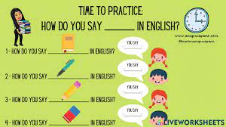

**LINKS WEEK 1**

In this link you will find: <https://www.youtube.com/watch?v=90LfcLAjLiI>

In this link you will find:<https://www.youtube.com/watch?v=tgVtVoxzwDI&t=10s>

In this link you will find:<https://www.youtube.com/watch?v=Gr1vs2QaZrc>

In this link you will find:<https://www.youtube.com/watch?v=wsDPrZnRxic>

In this link you will find:<https://www.youtube.com/watch?v=coI1jElTEls>

In this link you will find:<https://www.youtube.com/watch?v=oJXlff0gaD8>

**LINKS WEEK 2**

<https://www.youtube.com/watch?v=WX8-MPuv5gs>

<https://www.youtube.com/watch?v=bYeZKzHV0Hs>

<https://www.youtube.com/watch?v=yOJkygDGWvU>

<https://www.liveworksheets.com/ma1901603ig>

**LINKS WEEK 3**

<https://www.youtube.com/watch?v=spVsC4xBYac>

# <https://www.youtube.com/watch?v=RjZ5aPpq98c>

<https://www.youtube.com/watch?v=teKyQ79GbXk>

<https://youtu.be/EuAjgo6NSVM>

<https://www.youtube.com/watch?v=lMRTtUrSFOc>

# <https://youtu.be/yhOJZwLG8C4>

**LINKS WEEK 4**

<https://www.youtube.com/watch?v=mmLXJESFL9s>

<https://www.youtube.com/watch?v=i2yhyaNb4ac>

<https://www.youtube.com/watch?v=_HPWNOV4xdE>

<https://www.youtube.com/watch?v=UwU7akjlzp4>

<https://www.youtube.com/watch?v=_GjF7tYwJ8E>

<https://www.youtube.com/watch?v=_Z0flCbLq1w>

POWER POINT PRESENTATIONS

Unit 6 5th grade Sports, by Dana Mena Cueto

Unit 6 5th grade Last weekend, by Dana Mena Cueto

Unit 6 5th grade Places to visit in Atenas, by Karla Rodríguez

**Elaboración:**

Weeks 1 and 2: Laura Ugalde Bolaños, Escuela Alice Moya

Carmen Quesada Campos, Escuela San Juan

Weeks 3 and 4: Karla Vanessa Rodríguez Sánchez

Glenda Rodríguez Chaves

**Revisión final y edición**

Ronald Vargas Chavarría, Asesor regional de inglés

Dirección regional de Educación de Alajuela

Randall Centeno Hernández, Asesor nacional de inglés, Departamento de Primero y Segundo Ciclos

Ana Isabel Campos Centeno, Asesora nacional de inglés, Departamento de Primero y Segundo Ciclos